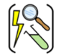

Year Three – Animals including humans
Subject Specific Vocabulary
nutrients | A substance used by a living thing to survive and grow.
carbohydrate | A substance found in food which gives us energy.
protein | A substance found in foods which helps us to grow and repair.
fibre | A substance found in food which helps us to move through our gut.
diet | The foods that a person, animal or community usually eat.
skeleton | A framework of bones supporting, protecting, and moving the body.
muscle | A soft tissue in the body that contracts and relaxes to cause movement of the skeleton.
contracts | In muscles, this means that they shorten to pull the bone.
 | Sticky knowledge
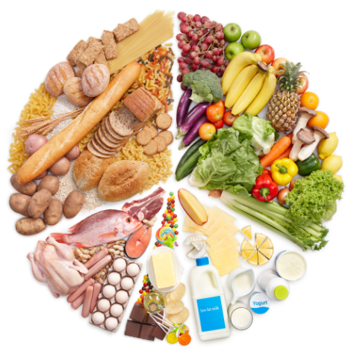 | The right food is important for a healthy body. Plants can make their own food; animals, including humans, cannot. We get nutrients from what we eat. All animals need the right amount of these nutrients.
 | A balanced diet should include food in different amounts from the main food groups: carbohydrates, proteins, fats, fruit and vegetables and dairy.
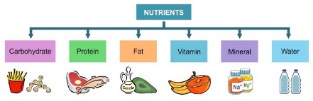 | Carbohydrates are needed for energy. Proteins are needed for growth and repair. Vitamins and minerals are needed for healthy cells. Fats are needed for energy. Fibre is needed to help food move through the gut.
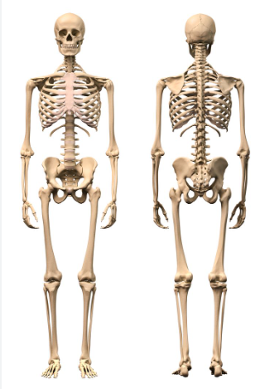 | The skeleton has three jobs:  1. Protecting your body parts (for example: skull – protects the brain; ribs – protect the heart and lungs; backbone – protects the spinal nerve).  2. Supporting your body – it lets you stand upright and holds the body together.  3. It lets you move – muscles are joined to the bones. The bones have joints so the skeleton can bend.
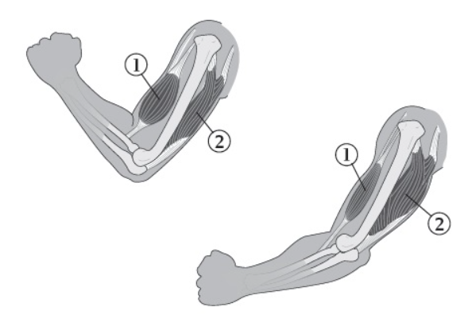 | Muscles and joints allow movement. Muscles always work in pairs.  To move a joint, one muscle gets shorter (contracts) and pulls the bone while the other muscle gets longer (relaxes). When a joint is moved back, the relaxed muscle contracts and the contracted muscle relaxes.
Aspirational Scientist:
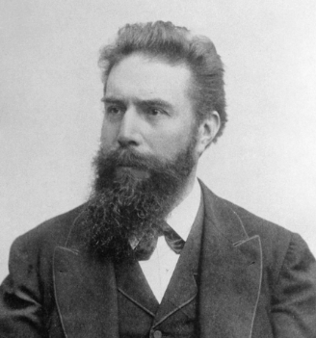
Wilhelm Conrad Röntgen was a German scientist who produced and detected electromagnetic radiation in a wavelength known as X-rays (what we now use to see bones)!

Working Scientifically
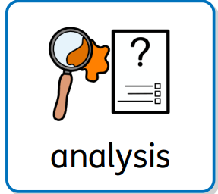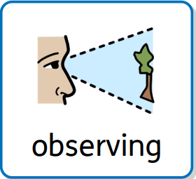
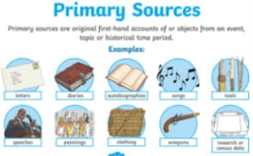
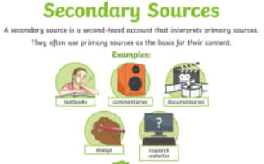
Primary and Secondary sources can help us to find out information

