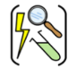

Aspirational Scientist:
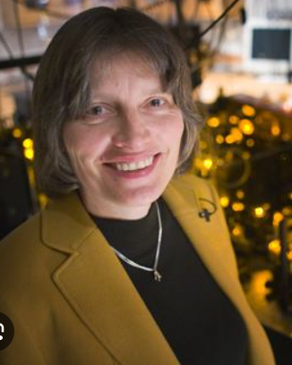
Lene Hau is a Danish physicist who In 1999, she led a Harvard University team who succeeded in slowing a beam of light to about 17 metres per second, and, in 2001, was able to stop a beam completely.
Year Three – Light
 | Sticky knowledge
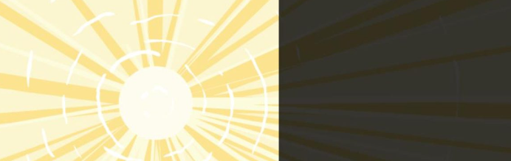 | Light is needed in order to see things. You can see because your eyes take in light from whatever you’re looking at. Darkness is when there is no light.
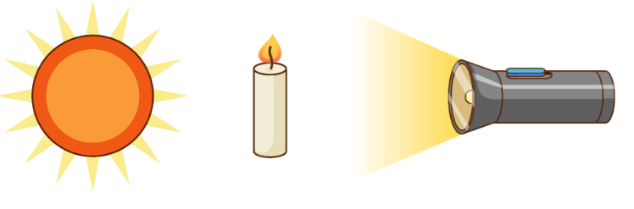 | Light sources include the sun, candles, or torch.  Non-light sources include the moon, planets or mirrors.
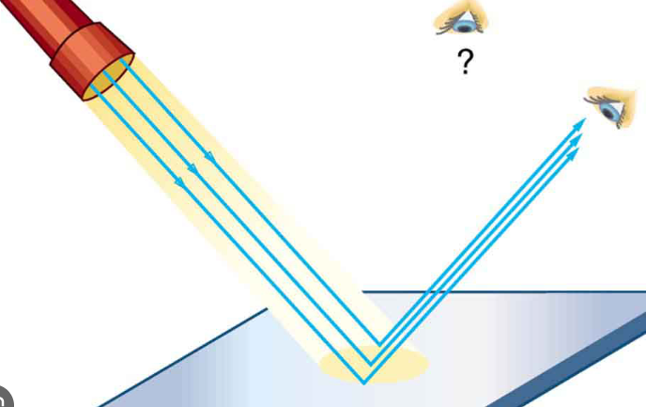 | Some objects seem bright but are only reflecting light from elsewhere. Reflecting means light bouncing off an object and not being absorbed.
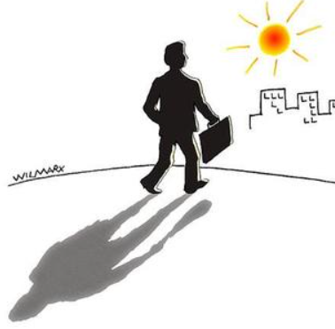 | A shadow will be formed if an opaque material blocks the light from travelling. Shadows can change size.
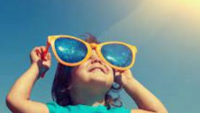 | Light from the sun can damage our eyes. You can protect your eyes by wearing dark glasses or a sunhat/cap when you’re out in bright sun light.
Subject Specific Vocabulary
light | A form of energy that allows visibility.
darkness | The absence of light.
opaque | An object that does not allow light to be passed through.
light source | A thing whose purpose is to produce light.
reflect | When light bounces off an object.
shadow | When travelling light is blocked by an opaque object it creates a shadow.

Working Scientifically


