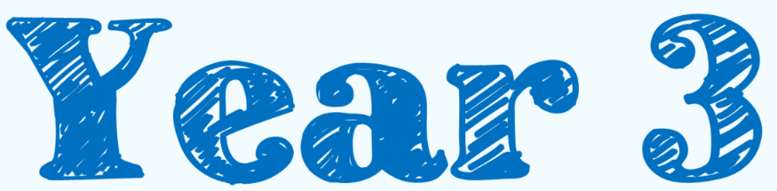  Spring Term 2023 |  | 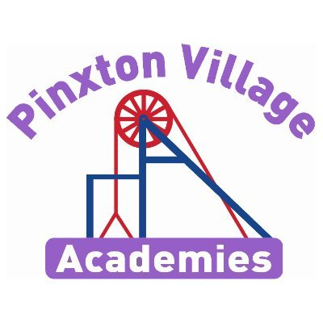
Year 3 Newsletter

Welcome back!

We hope you all had a fantastic Christmas break. We are really looking forward to getting this new year started with lots of exciting things happening.
As a reminder, healthy snacks such as fruit or cereal bars are allowed in school for break times.

Please, if you have any concerns, don’t hesitate to come and talk to us.
Year 3 Team

Reading Diaries and Books  Your child will regularly read their book in class and we will look at their diaries every Friday.  Please make sure your child brings their book and diary to school every day. Please also try and read with your child regularly and sign their organiser to say they have read every day | PE Kits  PE for Year 3 will still be on Mondays and Thursdays. Children will still come to school in their PE kits on these days.  Children will be unable to join in with the sports coach if PE kits are not in school. Also a reminder that earrings are not to be worn during PE.
Important Dates | Homework  Spelling tasks will be given fortnightly. Children are also expected to read every day at home, with their diaries being signed, and complete their times tables daily.
  Event | Dates
  Enquiry Hook -History workshop | 13th January
  Creswell Crags | 24th March

Is it survival of the fittest?

This term our enquiry question is ‘Is it survival of the fittest?’ This is a history-based enquiry, because there is a poverty of experience and aspiration of themselves within the school community, we want to broaden our children’s horizons and not only higher their aspirations but instill higher aspirations for the world. We want to develop a sense perspective and understanding of how their own lives impact on the world. Building on their learning of the local context and how they fit in to the wider world community. Throughout the term we will be learning through the ages of the Stone Age, Bronze Age and Iron Age. Focusing our attention on the skills and advances that helped us to survive. We will begin with experiencing our very own archaeology day and ending with a visit to Creswell Craggs.

Deepening Knowledge Task

Your home learning challenge to deepen your understanding
Reading    Reading is the gateway to the curriculum. We will be reading the text The Boy with the Bronze Axe by Kathleen Fiddler. Our focus on the skills of reading will be to understand and retrieve information. When you read with your child, please ask them questions about what they have read so they can demonstrate their understanding. |   Writing  This term we will be writing our own Stone Age narrative based on The Stone Age boy. We will also be writing a recount on the Lindow Man and having a balanced argument on which Age was the best for survival.  Research the prehistoric era and create a bank of descriptive words and phrases that you can use in your narrative. |  | Maths  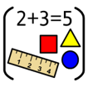  We follow the White Rose scheme in Maths. Follow the link below and you can follow lesson by lesson what your child is learning in school. https://whiterosemaths.com/homelearning/year-3/  This is a great resource to support your child and for you to see how we teach maths.
Science

In science, our focus will be Biology and we will be learning about Animals including Humans
To develop your learning at home, use
the following link will provide further learning in this area
https://classroom.thenational.academy/lessons/what-are-the-major-bones-in-the-human-body-69gpac
  RE  We follow the Derbyshire Syllabus. This term, we will be learning about why people pray. |  | PSHE    We teach PSHE through the PSHE Association.  This term we will be focusing on communities and careers.
Computing    We teach Computing through Purple Mash. This term we will be learning about how to stay safe online. The following links maybe helpful  https://www.saferinternet.org.uk/advice-centre/young-people/resources-3-11s  https://www.nspcc.org.uk/keeping-children-safe/online-safety/ |  | PE    In PE we will be learning the skills of hockey and football (outdoors) and handball and dance (indoors).

