Subject Specific Vocabulary
tempo change | Changing from fast to slow.
dynamic variation | Varying the dynamics during a performance can make it sound more interesting
structure | Structure is how the music is put together into different sections.
genre | Music with similar characteristics is grouped together into a genre (e.g. Jazz, Pop, Easy Listening, Classical)
melodies | Melodies ascend, descend, leap and have repeated notes.
practise | Repetitive actions, over and over.
memory/memorise | Memorising songs can help us to sing more fluently and with expression.
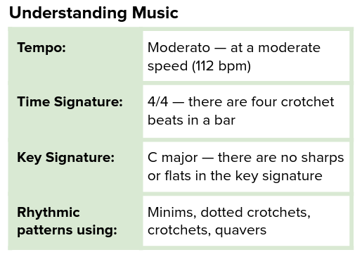

Year Five – Music: How does music connect us with our past?
How does music bring us together?
 | Sticky knowledge
 | Songs contain the interrelated dimensions of music and these are what make songs unique. This is called dynamic variation.
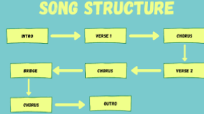 | Songs can have different structures.
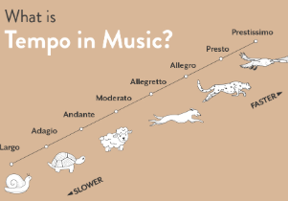 | Changing the tempo of a performance can make it sound more exciting (faster) or calmer (slower)
 | Practising songs, little and often, can help to sing fluently and from memory.
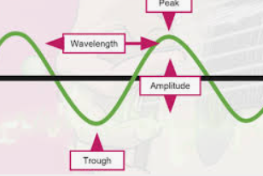 | When practising instruments, using notation can help have awareness of pitch.
 | When practising instruments, using notation can help the quality of sound produced.



