
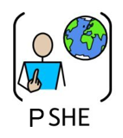
Year Four – PSHE Autumn

 | Sticky knowledge
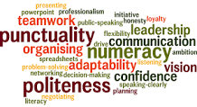 | Everyone has different personal qualities and strengths. It’s important to aim high to improve on weaknesses and not be afraid to make mistakes.
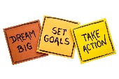 | Understand we all have personal strengths and that achieving my goals affects how we feel about ourselves. (Self-esteem)
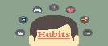 | Understand habits can have positive and negative effects. Healthy eating helps keep our bodies strong. Too much screen time is bad for us. Exercise is good for our muscles.
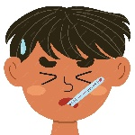 | If you start feeling tired, have a sore throat, or notice a runny nose, it might be a sign that you're getting a cold or the flu. Sometimes, your body might feel warm, or you might get a cough. These are your body’s ways of telling you that you need some rest, water, and maybe some medicine from a grown-up to help you feel better.
 | People in our community help each other in lots of different ways.
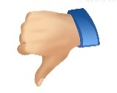 | Sometimes, friends might try to influence you to do things you’re not sure about, like saying something unkind or breaking a rule. This is called "peer pressure."
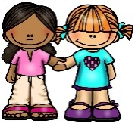 | When we act in a kind or unkind way, it can make other people feel happy or sad. For example, if you say something nice, it can make someone's day better, but if you say something hurtful, it can make them feel upset. So, it's important to think about how our words and actions can affect the feelings of others.
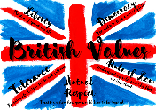 | Everyone has the right to be treated fairly and kindly this means that no one should be treated badly because of where they come from, what they look like, or what they believe. We all deserve respect and kindness. It’s just as important that we show it to others.
Subject Specific Vocabulary
self-esteem | How we value and perceive ourselves
self-worth | Feeling good enough and worthy of love
personal qualities | The characteristics, attributes or personality traits that make up and reflect who you are
goal setting | A goal is something that you determine you want, and you work hard to achieve it
managing set backs | An event that delays your progress or reverses some of the progress that you have made
courteous behaviour | Polite and respectful choices which benefit others
Human rights | Rights we have simply because we exist as human beings - they are not granted by any state
respect for self and others | Treating yourself and others with respect
safety | Being protected from or unlikely to cause danger, risk, or injury

