Subject Specific Vocabulary
Brahma, Ganesh, Lakshmi, Rama, Sita, Shiva, Vishnu | Names of Hindu Gods and Goddesses
Diwali | A Hindu celebration of light where good overcomes evil
Rangoli | A geometric pattern made outside houses to welcome in the Goddess Lakshmi- the goddess of wealth
Mandir | A Hindu temple and sacred place of worship
Hinduism | An Indian religion that is a way of life
Hindu | A follower of the Hindu religion
aum | The sacred symbol of Hinduism
shrine | A special place in a temple or home
lotus | A flower that is a symbol of beauty
Pooja thali | Items that go on a special offering plate
dharma | The duty to do the right thing
artha | To provide for your family in an honest way
caste | A class system used in India determined from birth
Diva lamp | A special light to show that God is present
Conch | Seashell
Moksha | To be saved from salvation


Year Four – RE: What does it mean to be a Hindu in Britain today?
?
 | Sticky knowledge
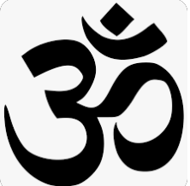 | Hinduism is a way of life rather than a set of beliefs and there are 4 aims of Hindu life, dharma, (a duty to do the right thing) kama, (enjoy the beauty of life) Artha (provide for family and society in an honest way) and moksha (leave the cycle of rebirth and become one with Brahma.
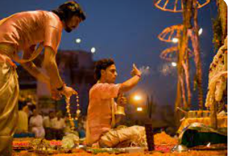 | Objects that you could find in a Hindu’ s house include: murtis, family shrine, puja tray and sacred texts. Puja usually consists of making an offering of flowers or fruit to an image of a god.
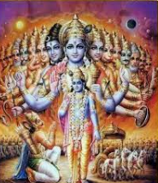 | Gods and goddesses of the Hindu faith, the beliefs about the ultimate reality they express, including concepts of karma, dharma and Brahman.
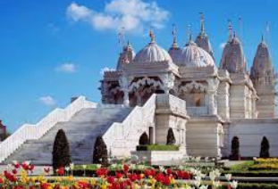 | A mandir is a place of Hindu worship.
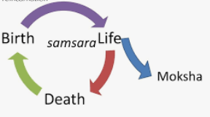 | Moksha is the ultimate aim in life for Hindus. It means to be saved (salvation).
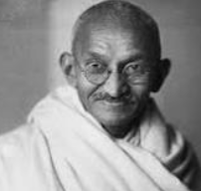 | Mahatma Gandhi is a man who devoted his whole life to fighting injustice.
Key Belief:
There are four main aims of Hinduism, the ultimate one is Moksha to end the cycle of rebirth and be at one with the God Brahma.

Key Belief:
Hindus follow the religion of Hindu. This religion is a way of life.




