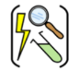

Year Four – States of Matter
Subject Specific Vocabulary
states of matter | Materials can be one of three states: solids, liquids or gases. Some materials can change from one state to another and back again.
precipitation | Liquid or solid particles that fall from a cloud as rain, sleet, hail or snow.
condense | Turn a gas into a liquid.
evaporate | Turn a liquid into a gas.
particles | A basic unit of matter that has energy.
freeze | Liquid turns into a solid during the freezing process.
solid | These are materials that keep their shape unless a force is applied to them. They can be hard, soft or even squashy. Solids take up the same amount of space no matter what has happened to them.
gases | Gases can spread out to completely fill the container or room they are in. They do not have any fixed  shape but they do have a mass.
liquid | Liquids take the shape of their container. They can change shape but do not change the amount of space they take up. They can flow or be poured.
melt | This is when a solid changes to a liquid.
water vapour | This is water that takes the form of a gas. When water is boiled, it evaporates into a water vapour.
 | Sticky knowledge
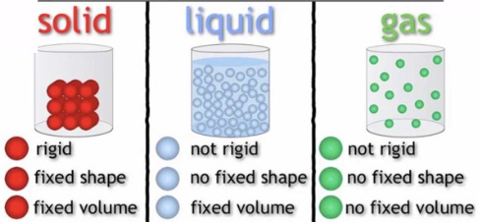 | All things are composed of a material in one of three states of matter: solid, liquid or gas.
 | All things are made of particles (tiny building blocks) and that these are organised differently in different states.
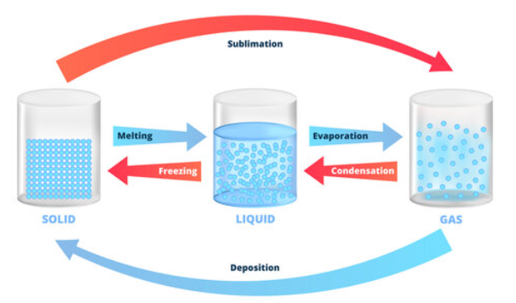 | Materials can change state when temperature changes.
 | When solids turn into liquids, this is called melting and the reverse process is called freezing
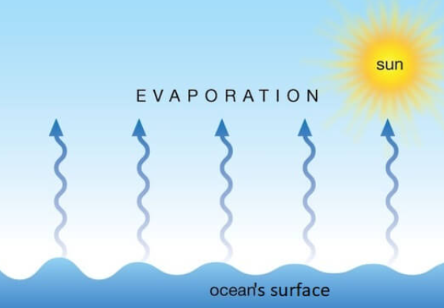 | When liquids turn into gases, this is called evaporation and the reverse process is called condensation.
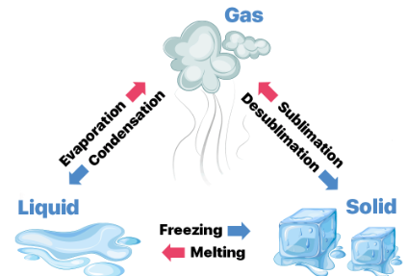 | When a solid turns into a gas without passing through the liquid state, this is called sublimation.
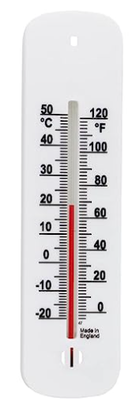 | The melting point of water is 0°C and the boiling point 100°C .
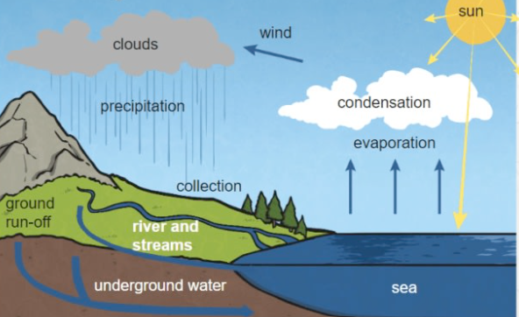 | Water flows around our world in a continuous process called the water cycle.
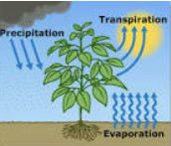 | When evaporation, occurs from the surface of plant leaves this is called transpiration.
Aspirational Scientist: 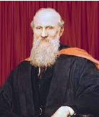
William Thomson, who is better known as Lord Kelvin, determined the temperature of absolute zero (the coldest possible temperature).
.
Working Scientifically
Observation  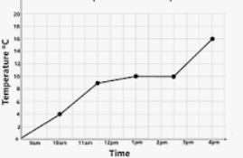 Recording

