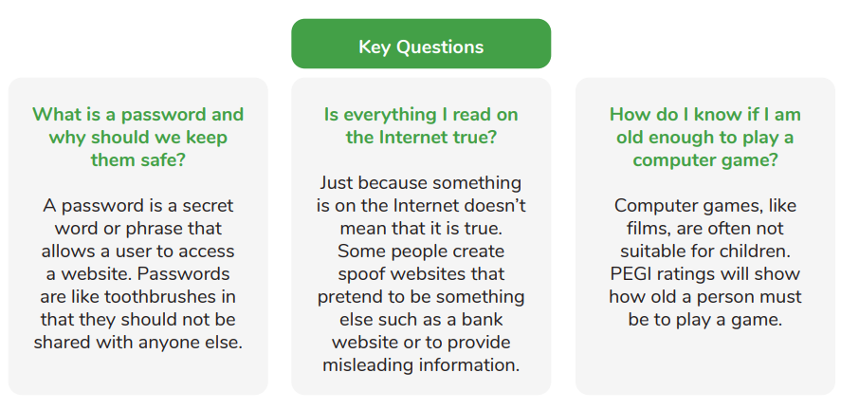
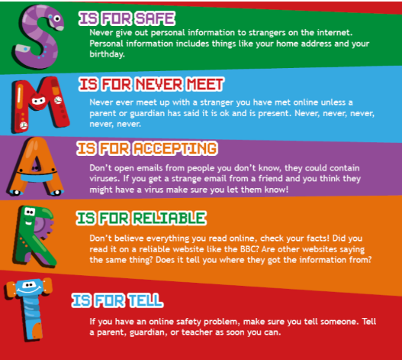

Year Four – Computing: Autumn
 | Sticky knowledge
 | You can block and report people on games and social media.
 | Trusted adults are parents, carers, teachers and family
 | Tell a trusted adult if something or someone upsets you online.
 | Online behaviour should be the same as face-to-face behaviour
Subject Specific Vocabulary
Acceptable | Acceptable means something is good enough to be allowed, approved, or agreed to.
Unacceptable | Unacceptable means not good enough to be allowed or approved.
Reporting | Reporting means telling someone important information, usually about something that happened.
Inappropriate | Inappropriate means not right or not okay for a certain place, time, or situation.
Content | Content refers to the things you see online. This includes pictures, music, videos and writing.

