

Year Four – Geography: Do we need water or does water need us?
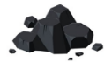 | Sticky knowledge
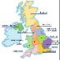 | A region is an area made up of counties. A county is a large area of land (which includes cities) that divides up a country. Derbyshire is in the region of the East Midlands. Pinxton is in the county of Derbyshire
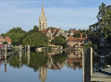 | Most cities are located near river because the river is a water source for farming and transport, this means that a town would never go hungry and they could trade good easier.
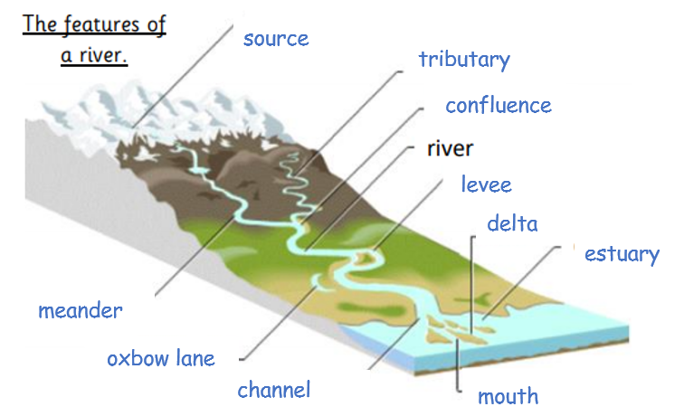 | Rivers begin at their source and flow into the sea. The upper course of a river is where the river is at its fastest. The middle course of a river is where it becomes wider and deeper and will bend more. The lower course of a river is very flat.
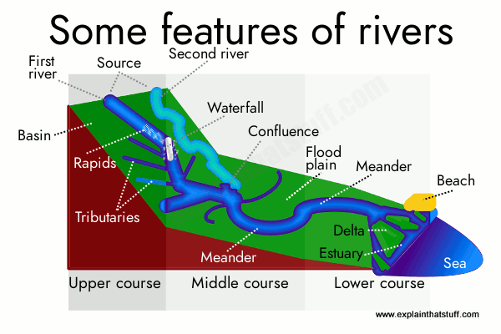 | The physical features of a river include:  Source: where a river starts in higher ground. River mouth: the end of a river where it meets the coast and drains into the sea, or sometimes a lake. Tributary: a smaller river, or stream, which flows into a larger river. Confluence: where a tributary meets another river. Meander: a natural bend in the river. Flood Plain: the area onto which a river floods, usually in the lower course.
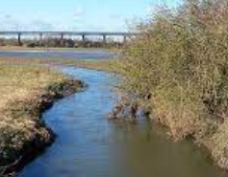 | The Thames, Severn, Mersey, Trent, Derwent and Ouse are major UK rivers. The River Erewash is our closest river. It was important to our area during the industrial revolution
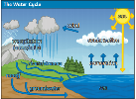 | The world’s water moves between lakes, rivers, oceans, the atmosphere and the land in an ongoing cycle called the water cycle.
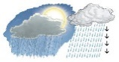 | Precipitation will soak (or “infiltrate”) into the soil and slowly move through the ground until eventually reaching a river or the ocean. Floods usually occur when precipitation falls more quickly than that water can be absorbed into the ground or carried away by rivers or streams.
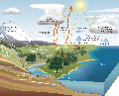 | Water cycle involves the exchange of energy, which leads to temperature changes. When water evaporates, it takes up energy from its surroundings and cools the environment. When it condenses, it releases energy and warms the environment. These heat exchanges influence climate.
Subject Specific Vocabulary
source | where a river starts in higher ground
river mouth | the end of a river where it meets the coast and drains into the sea, or sometimes a lake.
tributary | a smaller river, or stream, which flows into a larger river
confluence | where a tributary meets another river
meander | a natural bend in the river
flood Plain | the area onto which a river floods, usually in the lower course
evaporation | the process of turning from liquid into vapour
condensation | vapour turning into liquid when cooled.
precipitation | rain, snow, sleet or hail that falls to the ground
transpiration | Water which is evaporated through it’s leaves
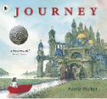
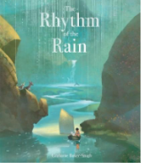
Exciting texts!
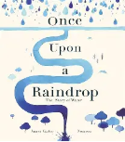
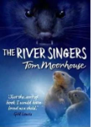
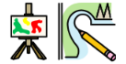
Enhancer Sticky Knowledge
Claude Monet was an influential impressionist French artist. Claude Monet was the founder of impressionist
painting. Claude Monet lived from 1840 to 1926. Claude Monet’s most well-known paintings were made using oil paint on canvas. Monet used fast brush strokes.

