  Autumn Term 2025 |  | 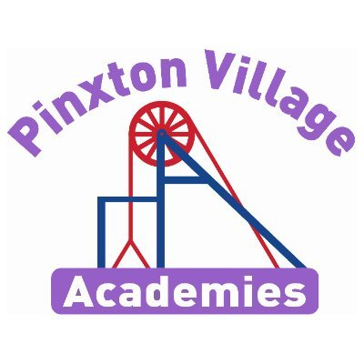
Welcome back!

It’s great to see you all back and ready to learn. We hope you have had a lovely summer break. We have lots of exciting learning planned for you and we’re looking forward to a great year!

As a reminder, healthy snacks (such as fruit or cereal bars) are allowed in school for break times.
If you have any concerns, please don’t hesitate to come and talk to us.
Year 4 Team- Miss Evans and Miss Kelvey.
Reading Diaries and Books  It is a homework expectation that your child reads at home to an adult every day, so please make sure you sign their diary to show this.  If you need any support with reading at home with your child, please don’t hesitate to contact us.  Your child will regularly read their book in class and will record any homework, spellings and reading to an adult in their diaries. Therefore, please ensure your child brings their book and diary to school every day. | PE Kits  On the day of PE, children will come into school in their PE kits. Pe days will be Tuesday and Wednesday.  They need to wear their purple Team Pinxton kits and suitable trainers. Children will be unable to join in with the sports coach if PE kits are not worn.  Please make sure earrings are removed and hair is tied up on these days.  Swimming will start in January. More information about this will be sent out nearer the time
Important Dates | Homework  Children are expected to read, practise their spellings and practise their times tables (on TT Rockstars) daily.  This homework is compulsory and is designed to build on the learning we do in school.  TT logins can be found in the back of your child’s home school diary  White Rose Maths videos are also shared in Class Dojo every week with the week’s learning.
  Event | Dates
  Hook day – walk to Pinxton wharf | TBC
  Severn Trent Assembly and Y4 Workshop | 11th September
  Seven Trent Water Bus Experience | 16th September
  Aspiration day | 2nd October
  Parent’s evening | 7th and 8th October
  Halloween Disco | 21st October
  World Science Day | 7th November
  Christmas Fair | 3rd December
  Carol Concert | 17th December

Follow us on social media, where we showcase our wonderful school and learning experiences.

Do we need water or does water need us?

This term, our enquiry is a geography focus. We will be learning about the physical features of rivers and how humans use them. We will also look at the impact of plastic pollution on the environment. In science, we will learn about the water cycle which links closely with our enquiry. We have an assembly and workshop with Severn Trent Water in our enquiry hook.

Deepening Knowledge Task
Reading  Reading is the gateway to the curriculum. When you read with your child, please ask them questions about what they have read so they can demonstrate their understanding.  In class we will be focusing on The River Singers by Tom Moorhouse. Listen to Tom talk about the story here:  https://www.youtube.com/watch?v=xMJO6GRS5UE  We will also be exploring Journey by Adam Becker. Watch the story here: https://www.youtube.com/watch?v=JyBTnJcboWo | Writing  This term we will be writing our own free-verse poem about rivers. We will also be writing an explanation of the water cycle.  Research the rivers and create a bank of descriptive words and phrases that you can use in your poem.  https://www.bbc.co.uk/teach/class-clips-video/articles/zbcmxyc |  | Maths  We follow the White Rose scheme in Maths. Follow the link below and you can follow lesson by lesson what your child is learning in school.  https://whiterosemaths.com/homelearning/year-4/  This is a great resource to support your child and for you to see how we teach maths.
Science

In science, we will be learning about the properties of solids, liquids and gases. We will investigate the effects of cooling and heating and how states of matter can change. We will also learn about the water cycle and how matter changes state in the process. Follow the link below to gain more knowledge:
Science, primary, Year 4 - Lesson listing | Oak National Academy
RE  We follow the Derbyshire Syllabus. This term, our key question is ‘What does it mean to be a Hindu in Britain today?’ We will learn about the key ideas and beliefs in Hinduism and compare the lives of a Hindu in Britain to our own lives. Explore Hinduism by watching a series of mini-clips here:  https://www.bbc.co.uk/teach/class-clips-video/articles/zfvkhbk |  | PSHE  We teach PSHE through the PSHE Association. This term, we will be learning about self-esteem. We will look at our skills strengths and interests, set our own goals and look at ways we can achieve these goals. The following video will give you a good head start on understanding self-esteem and how to be resilient after a tricky day!  https://www.bbc.co.uk/iplayer/episode/m000xh5v/bitesize-daily-911-year-olds-wellbeing-129-selfesteem
Computing  We teach Computing through Purple Mash. This term we will be learning about how to stay safe online and coding.  The following links maybe helpful:  https://www.saferinternet.org.uk/advice-centre/young-people/resources-3-11s  https://www.nspcc.org.uk/keeping-children-safe/online-safety/ |  | PE  In PE, we will be improving our fitness as this is so important to keep us physically and mentally healthy. Try PE with Joe Wicks to improve your fitness.  https://www.youtube.com/watch?v=Rz0go1pTda8

Sammy-Jo to add KO organiser here once checked and approved!

