

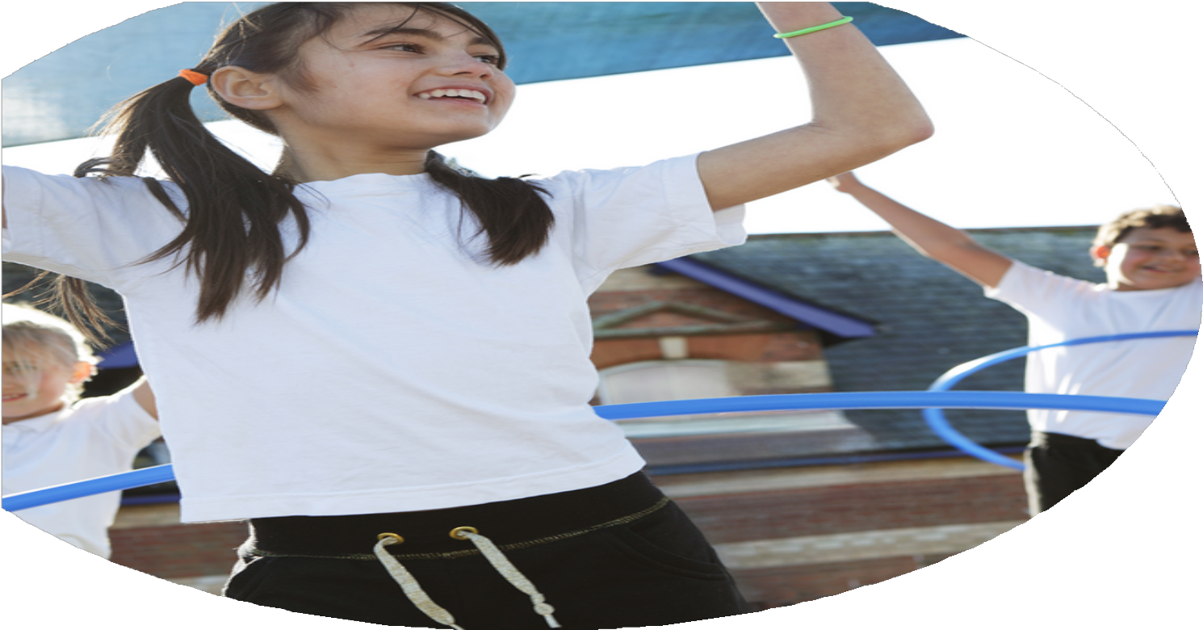
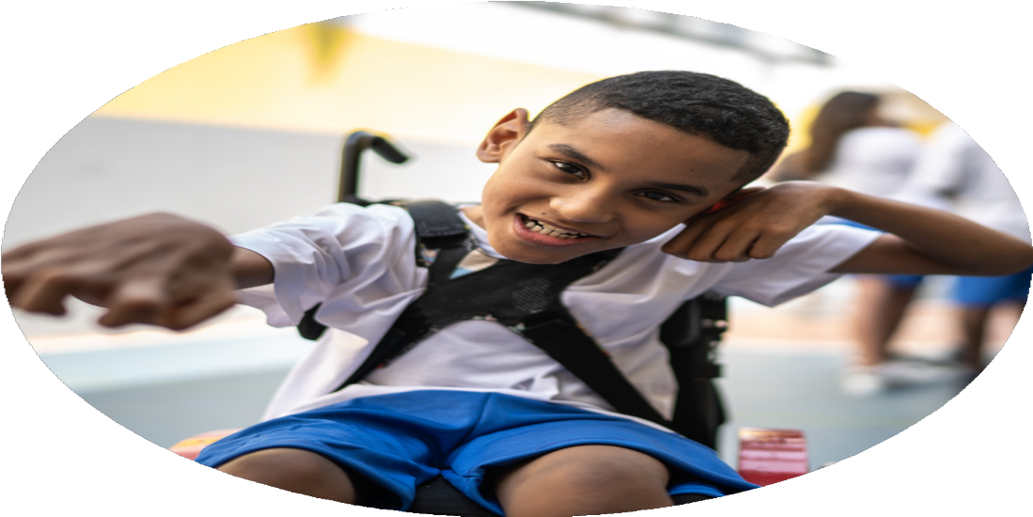
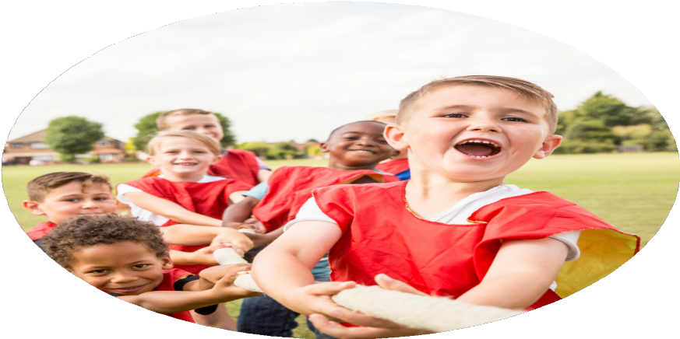



PE Funding

Evaluation Form

Commissioned by

Created by

Images courtesy of Youth Sport Trust

PE Funding Evaluation Form

It is intended that this template should be used as preparation for the completion of the statutory digital reporting tool being introduced this academic year. You can upload data (including swimming) from this template onto this platform once it becomes accessible.
All spending of the funding must conform with the terms outlined in the Conditions of Grant document. The template is a working document that you can amend/update during the year.
Based on your evaluation of last year’s funding you should decide what you intend to do this academic year, how you will do it, and what impact you expect it to have.

It is important that the funding is used effectively and based on your school’s needs.
You must use the funding to make additional and sustainable improvements to the PE and sport in your school. You must develop and add to the PESSPA activities that your school already offers.

Summative digital reporting from June 2025 will continue to include swimming and water safety information therefore funding can be used to provide top-up lessons where necessary to ensure pupils meet national curriculum swimming requirements.

What are your plans for 2024/25?

Intent
How are you going to action and achieve these plans?

Implementation
CPD with external coaches supporting confidence and competence
Sports coaches employed to support staff confidence through modelling, co-teaching and coaching in delivering whole class PE lessons. Sports coaches will work alongside all staff members, but intensely with ECTs to ensure that they feel confident and competent with the knowledge and skills to deliver a high quality PE curriculum.

Internal based extra-curricular opportunities
Sports coach to plan for and deliver increased opportunities for physical activity over lunchtime, including wider use of current school provision and the whole school site to be accessed safely for physical activity. Children will access a breath of lunchtime and afterschool clubs to further experience within sport, these will be targeted at children in receipt of PP, children with SEND needs and girls. Bespoke interventions will be accessed by children in receipt of PP, children with SEND needs and girls.

Top-up swimming lessons or broadening aquatic opportunities for pupils
Securing a swimming pool on site with qualified swimming instructors to deliver structured swimming lessons. The programme was accessed from Y3 to Y6, allowing each class to participate in regular, high-quality swimming sessions. Lessons were designed to develop core skills, water safety, and to meet the 25-metre requirement by the end of KS2.

Internal equipment and resources and internal use of educational platforms and resources
Ensure membership of Complete PE providing planning, resources and CPL to support subject lead and all staff delivering PE from Y3 to Year 6. Ensure all resources of a high quality and can be used to accessed a broad and balanced curriculum.

CPD with external coaches supporting confidence and competence
External sport coaches, empowering internal staff to have an increased understanding of the scheme of work and confidence in delivering whole class PE lessons. Children should have access to high quality PE teaching that will help them to learn and acquire the skills and qualities needed to participate in a range of sports. Teachers and feel confident and competent to deliver PE lessons that allow children to gain these skills and qualities. As a school, we need to focus on helping staff improve their subject knowledge and skills across the PE and sports spectrum.

Internal based extra-curricular opportunities
For pupils to be aware of the importance of regular physical activity through fun and engaging lunchtime activities. Active and engaging sporting activities and challenges will be implemented by a sports coach. The sports coach will target identified children and ensure that all children are active daily. Teachers will be empowered to offer after-school clubs to further children’s opportunities and experiences within sport.

Top-up swimming lessons or broadening aquatic opportunities for pupils
To ensure that all pupils from Year 3 to Year 6 have the opportunity to meet the national curriculum requirement of swimming 25 metres by the end of Year 6, while also promoting water confidence, safety skills, and regular access to swimming for all pupils.

Internal equipment and resources and internal use of educational platforms and resources
All staff will use Complete PE to ensure that there is a wide breath of sports and activities delivered as part of the curriculum. All children have access to a well-planned sequence of learning which is resourced well and provides a broad and balanced PE curriculum.

What impact/intended impact/sustainability are you
expecting?
How will you know? What evidence do you have or
expect to have?
CPD with external coaches supporting confidence and competence
- Teacher voice will show teachers subject knowledge and confidence has increased.
- Monitoring will show teachers are delivering high quality lessons for all children.
- Pupil voice will show children have a love and a strong knowledge and skills in PE.
- Assessment for learning procedures show children are achieving well in PE.

Internal based extra-curricular opportunities
- Identified children receive targeted support through interventions to enable them to become competent and confident sporting individuals.
- Analysis of lunchtime clubs and extra-curricular opportunities show increased engagement from the children.
- Assemblies to take place as an opportunity to celebrate achievements.
- Teachers to offer a breadth of after school clubs to extend their wider opportunities.

Top-up swimming lessons or broadening aquatic opportunities for pupils
- Percentage of Year 6 pupils able to swim at least 25 metres confidently and competently.
- Evidence of children learning and applying water safety and self-rescue skills.
- Attendance records showing consistent participation in swimming lessons across all targeted year groups and interventions in place for specific children.
- Pupil voice will show children’s increased confidence, enjoyment, and perceived progress in swimming.

Internal equipment and resources Internal use of educational platforms and resources
- Continue membership of Complete PE to ensure a sequenced progressive PE curriculum.
- Curriculum is clearly mapped out to ensure the different types of knowledge build progressively.
- Monitoring shows lesson delivery (including resources being used) are of a high quality
CPD with external coaches supporting confidence and competence
Teachers have observed then taught alongside the sports coach PE sessions across the curriculum. Teachers have increased knowledge of how to structure a PE lesson and strategies to use to enable clear development of pupil’s knowledge and skills. This will empower teachers delivering PE lessons, to feel more confident in delivering high quality lessons for all children.

Internal based extra-curricular opportunities
As a school we will work to organise a wide variety of sporting opportunities and activities for all pupils, including girls, those in receipt of PP and those with SEND needs. Teachers will offer after-school clubs to further children’s opportunities and experiences within sport. All children are taking part in active lunchtimes with personal challenges and sporting activities led with expertise. The role of the sports coach will be maximized to deliver vast opportunities through extra-curricular clubs, interventions and implement intra-school competitions.

Top-up swimming lessons or broadening aquatic opportunities for pupils
By starting swimming lessons from Year 3, we are building a progressive model that supports pupils over multiple years. This approach also enables more pupils to access swimming regularly, embedding swimming as a key part of our school’s physical education offer.

Internal equipment and resources Internal use of educational platforms and resources
PE to maintain a high profile at the school. The children will know that PE is a fundamental aspect to their physical and mental wellbeing. All staff will use Complete PE to ensure that there is a wide breath of sports and activities delivered as part of the curriculum. All lessons have been mapped onto our PVA curriculum map, therefore skills and knowledge throughout the year and allows children to build on learning.

What impact/sustainability have you seen?
What evidence do you have?



Pupil voice
Teach voice
CPD with external coaches supporting confidence and competence
- Teacher voice shows teachers subject knowledge and confidence has increased
- Pupil voice shows children have a love and a strong knowledge and skills in PE

- The PVA lesson design model supports the learning being presented in clear manageable steps. Teachers use AFL consistently throughout the PE lesson to ensure that all children are ready for the next stage of the lesson design.
- At the end of KS2 100% of the children have achieved the end point statements
Hundreds of children from schools within the Flying High Partnership join together for athletics events | Flying High Partnership

Internal based extra-curricular opportunities
Of the targeted interventions provided 58% of children are in receipt of Pupil Premium and 40 % are on the SEND register
- Uptake has increased throughout the year in sports after school clubs for girls. In the summer term 50% of the children attending are girls compared to 30% in the Spring term
- 41% of the children signed up for the basketball afterschool club was in receipt of Pupil Premium
- Up to 20% of the children who attended sports afterschool clubs are on our SEND register.
- Teachers to offer a breadth of after school clubs to extend their wider opportunities.
- A variety of sports afterschool clubs have been offered this year including multi-sports, dodgeball, football, basketball, badminton, athletics, chess

Top-up swimming lessons or broadening aquatic opportunities for pupils
- 79% Percentage of Year 6 pupils able to swim at least 25 metres confidently and competently.
- 98% of Year 6 children successfully completed water safety and self-rescue skills sessions
- https://www.flyinghighpartnership.co.uk/news/swimming-pool-initiative-is-a-stroke-of-genius-for-pinxton-school-children/

Internal equipment and resources Internal use of educational platforms and resources
- PVA PE Curriculum Map V4.docx
- Teachers use the Complete PE to plan their lessons, ensuring the correct resources are used accordingly

CPD with external coaches supporting confidence and competence
Teachers have had lots of opportunities for CPL which they have successfully implemented into their lesson delivery. All teachers, especially ECTs have enjoyed developing their practice and gaining confidence in the subject. This has impacted the children because we have a consistent approach to PE with all staff sharing a passion for getting it right for our children. Like our teachers, children are keen to improve their skills and learn new skills alongside their peers.

Internal based extra-curricular opportunities
Lunchtime and after school sports clubs have been accessible for all children, including children in receipt of PP, children with SEND needs and girls. We are keen to sustain the high profile of PE in school with our carefully planned timetables and range of intra-sports competitions. Through careful, analysis of clubs we are eager for more teachers to offer after-school sports clubs to supplement the sports clubs that we already offer, this will be aligned with our enhanced ‘democracy day’. Children are confident and competent when talking about PE and sport in school. Many children have been inspired to take part in extra clubs out of school time as well as attending their after-school clubs.

Top-up swimming lessons or broadening aquatic opportunities for pupils
This provision will be sustained through ongoing partnerships with the swimming facility and instructor, with dedicated funding allocated each year. We are building a progressive model that supports pupils over multiple years, increasing the likelihood of every child achieving the required standard. This approach also enables more pupils to access swimming regularly, embedding swimming as a key part of our school’s physical education offer.

Internal equipment and resources Internal use of educational platforms and resources
Complete PE has been used consistently across school to ensure that there has been a breath of sports and activities delivered as part of the curriculum for pupils.

