
Year Two – PE: Autumn 1
 | Sticky knowledge
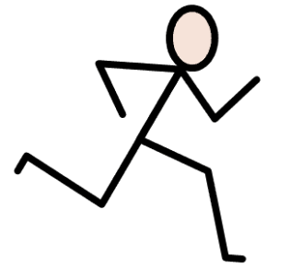  Locomotion:  Dodging | Hitting, kicking, throwing and rolling can be used in a game to attack or outwit an opponent.
 | Hitting, kicking, throwing and rolling can be used to score points/ goals.
 | Hitting, kicking, throwing and rolling can be used to gain and keep possession.
 | Possession means having the ball or piece of equipment.
 | Attacking means the team with possession and is able to score.
 | Defending means trying to stop the other team (the opponents) from scoring.
 | To create space, players should move away from defenders.
 | Creating space gives more time to make decisions and execute (successfully complete) a skill.
 | Standing closer to an opponent makes it harder for them (closing down).
 | Closing down, reduces time for an opponent to make a decision or execute a skill.
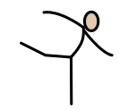  Gymnastics:  Pathways | Planning is preparing in advance.
 | Performing is carrying a sequence/action out in front of audience.
 | Linking is joining two or more movements together.
 | Travelling is moving from one place to another.
 | Flow means to move steadily and continuously within a performance
 | Rules are guidance to follow.
 | Sequences can be changed to make them different.
 | Rules can be applied in different order.
 | Starting is beginning. Finishing is ending.
 | Starting and finishing positions are controlled and still.
Subject Specific Vocabulary
attacker | When we are in control of the ball or trying to score points
defender | When we are not in possession of the ball and trying to stop others from scoring
space | An open area unoccupied by players
dodge | A method of moving quickly
tagging/tag | The method applied to stop attackers from moving

Subject Specific Vocabulary
champion gymnastics | Silent, pointing fingers and toes and able to make shapes/balances.
linking | Adding two movement together so they flow.
flow | When gymnasts move from one action to another without stopping.
transition | To move into and out of balances, movements or actions.
zigzag | Albrupt alternate right and left turns.
curved | A line that gradually deviates from being straight.
sequence | A combination of controlled movements.

