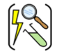

Working Scientifically

Year two – Animals including humans
 | Sticky knowledge
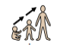 | The different stages that humans go through in their lives are baby, child, toddler, teenager, adult, old age. As we grow, we get bigger. We all start as babies and go through the different stages of life. When we become adults, we stop growing. As we become elderly, we get weaker.
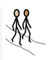 | Humans need food, water and air to survive.
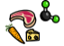 | Eating the right food is important. It provides us with the nutrients we need to keep healthy.
 | We must eat plenty of fruits and vegetables to keep you healthy. Carbohydrates give you energy. Proteins help you grow. Fats are needed for energy, but you don’t need too much of them.
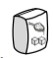 | Eating too much sugary food is not healthy and can damage your teeth.
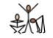 | Exercise is great because it’s really good for you, and makes you feel good. You need plenty of exercise to keep you healthy.
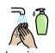 | It is very important to have good hygiene and keep our bodies clean inside and out to prevent infections, illnesses and diseases. Good hygiene will help to keep us healthy and stop us from spreading germs from one person to another.
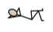 | Getting enough rest is important so we can grow, learn and stay healthy.
Subject Specific Vocabulary
baby | An animal at the start of their life.
child | A young person between 4 and 13.
toddler | A young person between 1 and 3.
teenager | A young person between 13 and 19.
adult | A person that is fully grown.
old age | A person over 60.
hygiene | How we keep clean.
balanced diet | Making sure we eat different types of food.
exercise | Working the muscles in our body to keep fit.
rest | Getting enough sleep.
protein | Foods that help us grow. E.g. meat, fish, nuts, pulses.
carbohydrate | Foods that give us energy. E.g. cereals, pasta, rice, bread, potatoes.
fruit and vegetables | Food from plants.
David is a naturalist and broadcaster. He has made many programmes for television about wildlife all over the world.

Aspirational Scientist:
David Attenborough
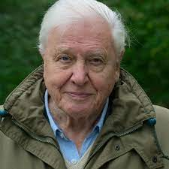

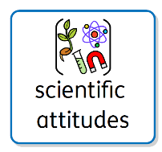
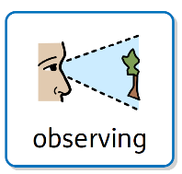
Primary and Secondary sources can help us to find out information

