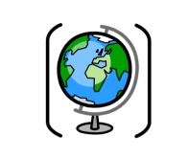

Year Two – Geography: Are we defined by our postcode?
 | Sticky knowledge
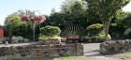 | A city is an area with a large population and a local government. An advantage of living here is having access to shops and more job opportunities. A disadvantage is higher population. A village is a community in a rural area. An advantage of living here is it is more peaceful. A disadvantage is it can be hard to get to places.
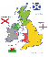 | The United Kingdom is made up of England, Scotland, Wales, Northern Ireland and has 3 surrounding seas which are English Channel, North Sea and Irish Sea.
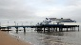 | The ocean, sea, beach and cliff are physical features of typical coastal areas of the UK. A port and harbour are human features of the UK. A port is a town or city with a harbour e.g. Hull. A harbour is where goods are loaded/unloaded from the sea.
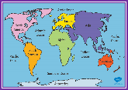 | A continent is a large, solid area of land made up of different countries. The continents are Europe, Asia, North America, South America, Africa, Australasia/Oceania, Antarctica. There are 5 oceans on Earth. They are the Pacific, Arctic, Atlantic, Indian and Southern oceans.
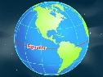 | The equator is an imaginary horizontal line around the middle of the Earth. The world can be split into four hemispheres – eastern, western, northern, and southern
 | Pinxton and Mugurameno are both villages with a smaller population than a city. Children in Pinxton and Mugurameno have to attend their local school. There is a river running through Mugurameno. People of Mugurameno build their own houses. Pinxton has good transport connections to the local city whereas Mugurameno is more remote with less connections.
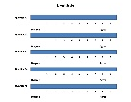 | A Likert scale is a rating scale used to measure opinions, attitudes, or behaviours. These statements are then interpreted to form a conclusion. A geographical investigation could include the following elements: Introduction and planning, methods and data collection, data presentation, data analysis, conclusions, evaluation.
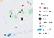 | A map is a detailed drawing/representation of a place charting the physical and human features which can be found there. Symbols and a key can help show where things are on a map
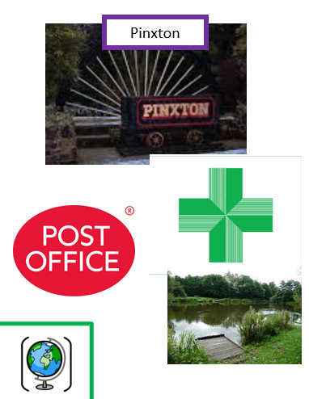 | Longwood is south of the church. John King is west of the Pharmacy. The Post office is north of the trainlines. The village hall is south of the mining wheel.
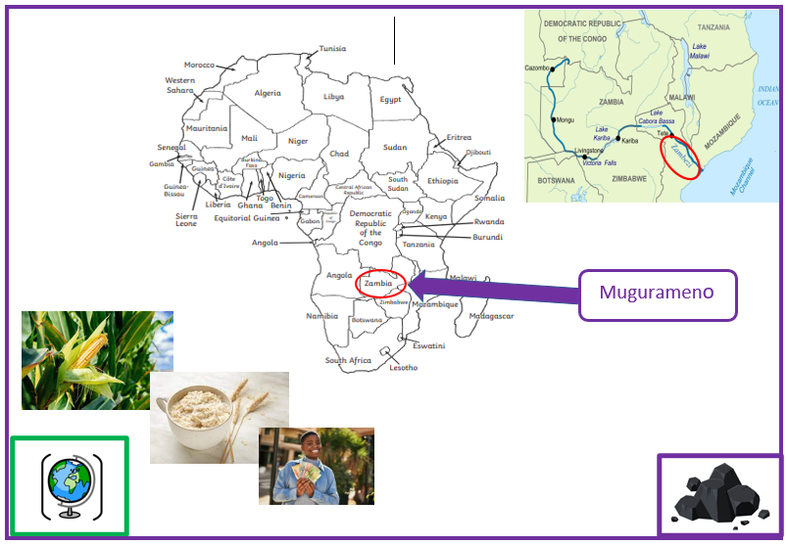 | Zambia (Mugurameno) is in the Southern hemisphere. Zambia is located on the continent of Africa. It can be found in south-central Africa.
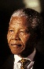 | Nelson Mandela was a significant individual. He was born in South Africa in 1918. He believed that everyone should be treated the same and fought against apartheid. He spent 27 years in prison. He was the first black President of South Africa.
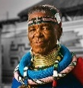 | Ester Mahlangu is a significant individual. She is one of South Africa’s most renowned artists and brought traditional mural paintings to international attention. Esther was born in South Africa in 1935. She was invited to be part of a 1989 exhibition in Paris which showcased artists from around the world. She was given a replica house to paint live in front of spectators.

Subject Specific Vocabulary
city | A city is an area with a large population and a local government
village | A village is a community in a rural area.
Pinxton | Pinxton is an ex-mining village in England in the UK.
Cleethorpes | Cleethorpes is a seaside town. It has a harbour.
Mugurameno | Mugurameno is a village in Zambia in Africa.
Zambia | A country in the continent Africa.
Likert scale | A scale showing data you have collected.
continent | A large solid area of land made up of countries.
equator | The equator is an imaginary horizontal line around the middle of the Earth.
Nelson Mandela | A significant person.
Ester Mahlangu | A significant person.
John King | A significant person.

Sticky Knowledge:

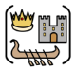
John King was a significant person from Pinxton because he invented the safety mining hook in 1873.


The primary colours are red, blue, and yellow. The secondary colours are green, orange, and purple. Tertiary colours are made by mixing primary and secondary colours. Blue and green make turquoise. Different amount of blue and red make violet and indigo. Red and purple make crimson.

Adding white makes a tint lighter. The more white that is added, the lighter the tint. Adding black makes a shade darker. The more black that is added, the darker the shade.

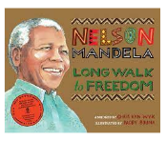
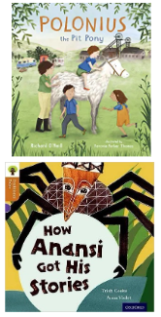
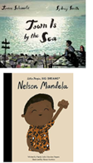
Exciting texts!

