

Year Two – Computing: Spring

Subject Specific Vocabulary
organise | To arrange things digitally so they are easy to find.
manipulate | To change or move something digitally.
retrieve | To find and open something stored digitally.
file | A piece of work saved digitally, like a picture or document.
folder | A place on the computer or on a device where you keep files together.
 | Sticky knowledge
 | Content can be saved in folders to make it easy to retrieve
 | Retrieving content means finding it and opening it
 | Manipulating content can change the structure and appearance
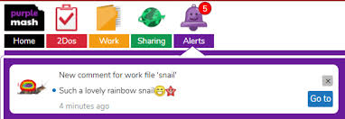 | Naming content allows easy retrieval





