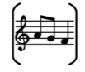

Year Two – Music: Spring

Subject Specific Vocabulary
dynamics | The varying levels of volume of sound in different parts of a musical performance.
pitch | The quality of a sound caused by the rate of vibrations producing it.
pulse | A single vibration or short burst of sound.
tempo | The speed at which a passage of music is or should be played.
timbre | The quality of sound.
mood | How the music makes you feel
legato | Smooth
staccato | Short and detached
expression | The way music is performed
symbols | Signs or pictures that show musical ideas.
graphic | A picture that represents sounds or music.
pattern | A group of sounds or actions that repeat.
rhythm | The pattern of long and short sounds.
steps | Moving or singing to nearby notes.
jumps | Moving or singing to notes that are far apart.
allegro | Music played fast and lively.
adagio | Music played slow and calm.
forte | Music played loudly.
unison | Everyone doing or singing the same thing together.
duet | Two people performing together.
actions | Movements you do to go with music.
lyrics | The words of a song.
reflect | To think about something.
composer | A person who writes music.
improvising | Making up music as you go.
musicians | People who play or create music.
 | Sticky knowledge
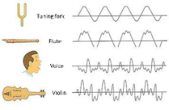 | Timbre is the quality of sound, which makes each person’s voice sound different, and each instrument sound different even when playing the same notes or tune.
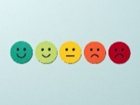 | Mood is how the music makes you feel. Different timbres can create different mood.
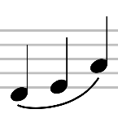 | Legato is smooth.
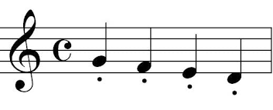 | Staccato is short and sharp.
 | Pulse is like the heart beat in your body, beating throughout the music
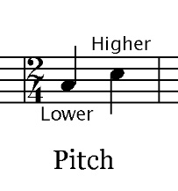 | Pitch is how high or low a musical note is and how this changes throughout songs
 | Tempo is the speed of the music (slow or fast)
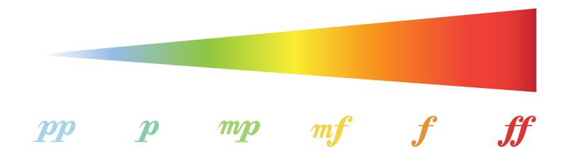 | Dynamics is the volume – how loud or quiet something is
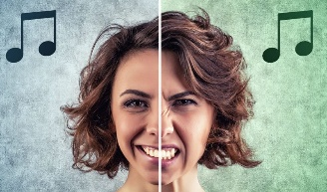 | Different timbres can create different mood
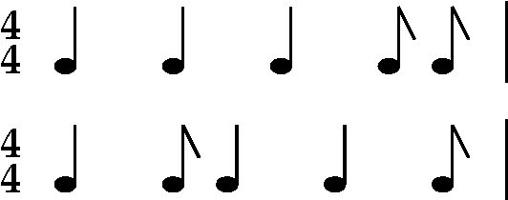 | Rhythmic patterns are sequences of long and short sounds.
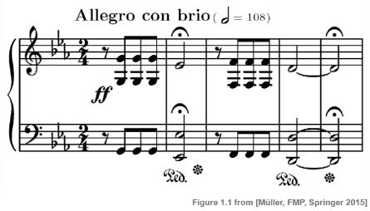 | Graphic scores can be used to record a piece of music so that others can play it.

