Subject Specific Vocabulary
happy | A good feeling or showing pleasure.
sad | A bad feeling or showing distress.
angry | Showing strong annoyance or disapproval.
frightened | Being afraid, scared or anxious.
calm | Not showing or feeling nervousness, anger or other feelings/emotions.
surprised | A feeling showing surprise because something has happened that you did not expect.
mood | A temporary state of mind or feeling.
Protected characteristics | These protect people from discrimination. It is the law to discriminate against anyone because of a protected characteristic.
age | The length of time that a person has lived or a thing has existed.
gender reassignment | The process of changing a person from male to female or female to male with an operation.
marriage | A union between individual people.
pregnant | Pregnancy is when a female mammal has an unborn baby inside her.
disabled | A physical or mental condition that limits a person’s movements, senses, abilities or activities.
race | The concept of dividing people into groups on the basis of various physical characteristics.
religion | What you believe about human beings’ relationship to a higher power (such as God). Religion teaches you a set of practises to live by.
sex | Whether you were born a girl or boy at birth.
pressure | When people try to get you to act a certain way, or try to get you to do something you might not want to do.
emergency | A situation in which a risk to health, life, property or environment is about to happen. Most emergencies need quick attention to prevent it from becoming worse.
 | Sticky knowledge
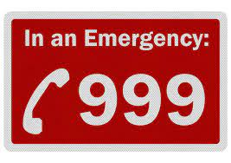 | In an emergency I need to ring 999 asking for the police, fire service or ambulance. I would need to share where I am and what has happened.
 | Good secrets are nice surprises and ‘bad’ secrets would make us feel worried.
 | Peer pressure is when your friends try to persuade you to do something.
 | Giving permission means you allow something to happen.
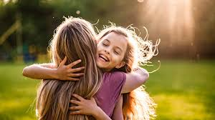 | You need to ask permission before you hug, kiss or touch someone else.
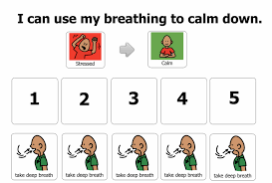 | To manage big feelings I can take deep breaths, talk to grown-ups, take myself away, go outside and have a walk.
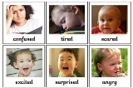 | There are lots of different feelings and I can feel these at different/certain times.
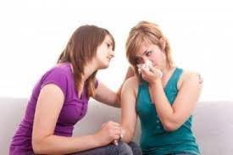 | Other people have certain feelings and I can recognise these.
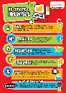 | To keep safe online we should, never speak to people we don’t know, keep our personal information a secret, use an avatar and a nickname. And if we are ever unsure we should talk to a trusted adult.
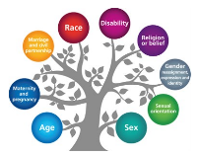 | There are 9 protected characteristics which stop people being discriminated against. They are: age, disability, gender, pregnancy, race, religion or belief, sexual orientation, marriage or civil partnership, sex, gender reassignment.
 | Respect means that you accept somebody for who they are, even when they're different from you or you don't agree with them.


