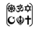

Year Two – RE: What can we learn from sacred books?
 | Sticky knowledge
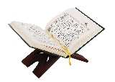 | The sacred text of Islam is the Qur’an.
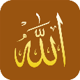 | sacred or holy means that people believe that they are from God.
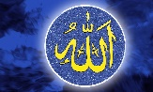 | the Qur’an is written in Arabic as Muslims believe that is how it was revealed to Prophet Muhammed.
 | Muslims view Muhammad as God’s Prophet (using Peace be upon him after his name)
 | Muhammad is an inspiring person who spreads the lessons in the Qur’an.
Subject Specific Vocabulary
Qur’an | the sacred text of Islam, considered by Muslims to contain the revelations of God to Muhammad.
Sacred | connected with God.
Arabic | the language of Arabic people. The Qur’an is written in Arabic.
Prophet | a person regarded as an inspired teacher or proclaimer of the will of God.
Message | a religious message is a lesson to be passed on.
Muhammad | the Prophet who spreads Allah’s word.
Allah | God.
Key Belief:
Muslims follow the religion of Islam. They follow the example of the prophet Muhammad.

Key Belief:
The holy book of Islam is called the Qur’an. It should be wrapped when not in use and always placed off of the ground on a rack or table.


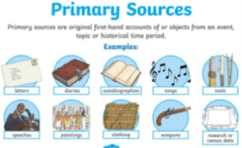
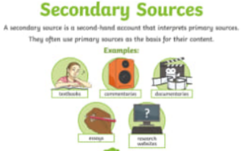

Primary and Secondary sources can help us to find out information

