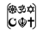

Year Two – RE: In what ways is a Mosque important to believers?
 | Sticky knowledge
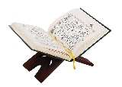 | Sacred/holy means a place that is connected to God.
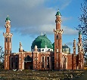 | In a Mosque you will find a Wudu, Calligraphy, prayer mat, prayer beads, Minbar, Mihrab, Muezzin.
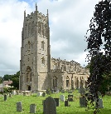 | Both Mosques and Churches are important places to people of faith.
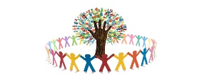 | Holy places are key pillars in the community and help to bring people together.
Subject Specific Vocabulary
sacred | Connected with God.
Mosque | A Muslim place of worship.
Wudu | Washing to be performed in preparation for prayer and worship.
prayer mat | A small carpet used by Muslims for kneeling on when praying.
prayer beads | A string of beads used to keep count while uttering prayers.
Minbar | A short flight of steps used as a platform by a preacher in a mosque.
Mihrab | A point in the wall which tells you the direction of Mecca to pray to.
Muezzin | A man who calls Muslims to prayer from the minaret of a mosque.
Minaret | A slender tower, typically part of a mosque, with a balcony from which a muezzin calls Muslims to prayer.

Key Belief:
A Mosque is the holy building for Islam. This is where traditions and practices of Islam take place.

Key Belief:
Muslims pray 5 times a day. These times are displayed within the Mosque.


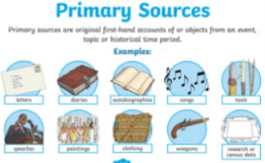
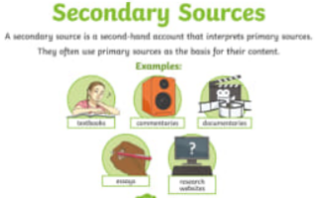

Primary and Secondary sources can help us to find out information

