 | Sticky knowledge
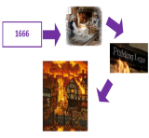 | The Great Fire of London occurred in September 1666. The Great Fire of London began in Puddling Lane in a bakery. The fire was caused by a bakery fire that quickly spread due to strong winds and the city's wooden buildings.
 | A timeline is a representation of a period of time in which important events are marked.
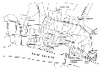 | Aerial photographs are often used to show features on a landscape; they can show the physical landscape of an area and the human impact on a landscape. Rivers can be identified through ribbon-like, often blue, shapes.
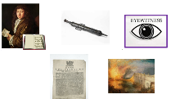 | Historical sources are the main way that we can interact with and understand more about past events. Historical sources can be documents, artefacts, oral histories, paintings, recorded sounds, images, photographs, relics and ruins. Samuel Pepys was an English diarist and a member of Parliament.
 | A primary source (also called an original source) is a source of information that was created at the time. It serves as an original source of information about the period/event/person. A secondary source is a document or recording that relates or discusses information originally presented elsewhere.
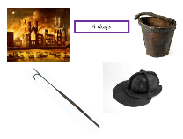 | The fire lasted for 4 days. To fight fires during this time, people would have used leather buckets to pick up water and metal hooks to drag buildings down and stop the fire spreading. The houses were built of wood and built closely together so the fire spread quickly.
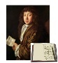 | Samuel Pepys was an English diarist and a member of Parliament. The detailed private diary that Pepys kept from 1660 until 1669 was first published in the 19th century and is one of the most important primary sources.
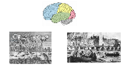 | Memory is personal and can affect versions of the same event differently. Memories can fade over time. Memories are often unreliable over time. Two people can remember the same event differently.
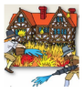 | The Great Fire of London has changed London, our fire service, fire safety, and how houses are built.
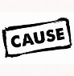 | A cause is something that makes something else happen. It could be an action, event, or decision that leads to a particular outcome. The fire caused change in London. There are human features that were built after the Great Fire that can still be seen in London today, such as St. Paul’s Cathedral.


Year Two – History: What things change and what things stay the same?
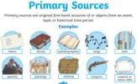
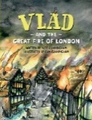
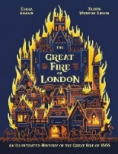
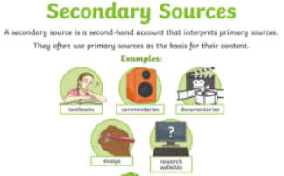
Subject Specific Vocabulary
Samuel Pepys | Samuel Pepys was an English diarist. His diary was an eyewitness account of the Great Fire of London.
leather | Leather is a strong, flexible and durable material obtained from the tanning, or chemical treatment, of animal skins.
cathedral | A cathedral is a church that contains cathedra (‘seat’) of a bishop.
narrow | A small width.
River Thames | A 215 mile long river flowing through the southern United Kingdom including London.
impact | A marked effect or influence.
national | Something that is common to a whole nation.
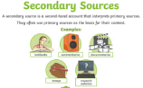
Primary and Secondary sources can help us to find out information
Exciting texts!


Enhancer Sticky Knowledge
- Fine media are smaller, more intricate materials such as sketching pencils (for more detailed art) Broad media are thicker/larger materials such as chalk.
- Contours are edges or outlines of an object. Colours can represent our emotions in art for example blue can indicate sadness whereas yellow is viewed as bright and cheerful. They can also show cool and warm tones.


Primary and Secondary sources can help us to find out information

