

Year Two – Materials
 | Sticky knowledge
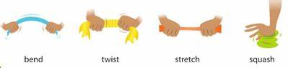 | The shape of some materials can be altered by bending squashing twisting and stretching.
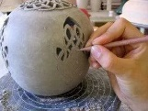 | Some changes are permanent. The shape of clay cannot be altered after it is heated.
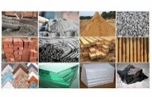 | We need to choose materials that are suitable for the intended purpose. I know we do this by considering the properties of the materials.
Subject Specific Vocabulary
bend | Change the shape by holding both ends and bringing them inwards together.
twist | Change the shape by turning your hands in opposite directions.
squash | Change the shape by pushing your hands together.
stretch | Change the shape by pulling the ends apart.
reverse | Can be returned to the original state.
permanent | Cannot be returned to the original state.
suitable | The material has the right properties for the intended purpose.
absorb | Liquid soaks into the material. E.g ink into paper.
Working Scientifically

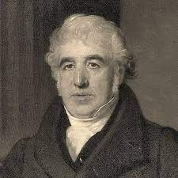
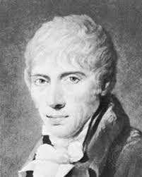

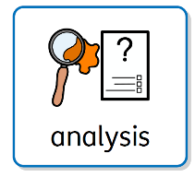
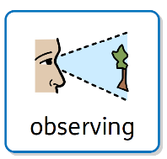
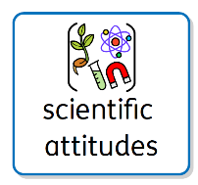
Charles Mackintosh was a Scottish chemist who invented a way to make fabrics waterproof. He invented the raincoat.
John McAdam was a Scottish chemist who invented a new way to build roads.

recording
planning
Aspirational Scientists:
Primary and Secondary sources can help us to find out information

