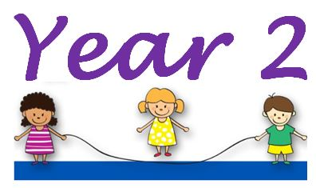  Autumn Term 2025 | 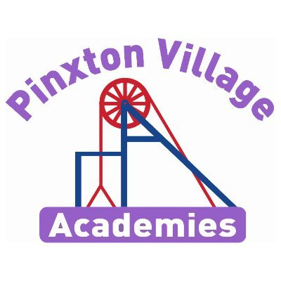
Welcome to Year 2!
We are thrilled to have had a lovely first day with Year 2. We look forward to seeing how much they progress over this term. They have already impressed us in the classrooms with their attitude to learning and know they will continue this.
‘Shoot for the moon, even if you miss you’ll land in the stars’

remember, if you have any concerns, please don’t hesitate to come and talk to us.
Mrs Goody and Miss Baines

Reading Diaries and Books  Your child will regularly read their book in class and we will look at their diaries daily. We have a 3 book approach with decodables: one book they are fluent with, one decodable to practise throughout the week and one library book to read for pleasure.  PLEASE make sure your child brings their book and diary to school every day as every spare moment we have in school we will try and read with your child. Please try and read with your child every day as becoming a reader is the most important part of your child’s education. We learn to read, to read to learn. Reading is the gateway to the curriculum.  We have reading breakfasts every term and hope to see you in school! You will also have the opportunity to be a secret reader to the children at story time. | PE Kits  At John King PE days will be Monday and Friday  At Longwood PE days will be Monday and Friday  Your child’s #TeamPinxton PE kit should be worn to school on the set PE days. These have been available to buy through parent pay. On PE days, please make sure earrings are removed and hair is tied up.
Important Dates | Homework  Children are expected to read, practise their spellings and practise their times tables (on TT Rockstars) daily.  This homework is compulsory and is designed to build on the learning we do in school. Please make sure children your child;s diary is signed daily or seek help if they are stuck.TT logins can be found in the back of your child’s home school diary.  White Rose Maths videos are also shared in Class Dojo every week with the week’s learning and these need to be watched each day.
  Event | Dates
  Aspiration Day | Thursday 2nd October 2025
  Parent’s Evening | Tuesday 7th and Wednesday 8th October 2025
  Siblings and individual photo day | Monday 13th October 2025
  Halloween disco | Tuesday 21st October 2025
  World Science Day | Friday 7th November 2025
  Children in Need | Friday 14th November 2025
  Christmas Fair | Wednesday 3rd December 2025
Are we defined by our postcode?

In Autumn, our enquiry question will be ‘Are we defined by our postcode’. This is a geography based enquiry because our school is based in an ex-mining village. We want them to have an understanding of our community’s heritage whilst expanding our children’s geographical knowledge of the United Kingdom. Throughout the term we will be learning about the historical and geographical importance of Pinxton. We will be learning about the countries that make up the United Kingdom and the seas that surround it. Follow the link below to learn more about this: https://classroom.thenational.academy/lessons/what-is-the-united-kingdom-71k32c?step=1&activity=video. We will then widen our knowledge by comparing and contrasting the seaside town of Cleethorpes with Pinxton and learning about the town of Mugurameno in Zambia, Africa. On the next page is a knowledge organiser showing the important knowledge we want the children to acquire during the enquiry. To support us with our learning we will be exploring the local area. Please say hello if you see us out and about in the first few weeks in September. More information about this coming soon!

Deepening Knowledge Task

Your home learning challenge to deepen your understanding
Reading  Reading is the gateway to the curriculum and is really important your children practice and apply the sounds they learn in school. We encourage your child to read every day of the week at home. This is monitored daily in school by class teachers.  In Autumn we will be reading to find out lots of information about Nelson Mandela. Listen and share this book at home and see how many different facts you can find out about him.  Nelson Mandela "Little People, Big Dreams" series  We vote on a class story everyday as part of democracy in school.  Reading challenge:  Can you read a book at home every weekend until October half term? | Writing  In Autumn, we will be writing a leaflet about our local area to demonstrate our knowledge. We will then be retelling our own version of the Anansi Tales. Share the story at home and create your own story map of the African tale.  English KS1: Anansi and the Moss-Covered Rock - BBC Teach |  | Maths  We follow the White Rose scheme in Maths. Follow the link below and you can follow lesson by lesson what your child is learning in school.  https://whiterosemaths.com/homelearning?year=year-2&term=autumn  This is a great resource to support your child and for you to see how we teach maths. We will share the weekly maths videos via Class Dojo from September.
Science
In science, we will be leaning about living things. We will start by thinking about how we change as we grow up and get older. We will think about ways we can be healthy. We will look at the amounts of different types of food we should eat, find out about the importance of the right amount of sleep and exercise and learn about the importance of hygiene.
We will then go on to learn how to identify whether things are living dead or never been alive and think about the different types of habitat that living things inhabit.

What do humans need to be healthy? - BBC Bitesize
Why is exercise so important? (thenational.academy)
RE  We follow the Derbyshire Syllabus. In Autumn, we will be learning about the Muslim faith.  https://www.youtube.com/watch?v=p_48luWFD8s  https://www.youtube.com/watch?v=rwNcnOMaea0 |  | PSHE  We teach PSHE through the PSHE Association. In Autumn, will learn about ourselves and others and how we are similar and different.  Play My First Day at School - BBC Bitesize  PSHE KS1/KS2: What makes me, me? - BBC Teach
Computing  We teach Computing through Purple Mash. In Autumn we will be learning about how to use technology safely. Below are some useful websites to support you.  https://www.internetmatters.org/?gclid=EAIaIQobChMIy7qxmqzP8gIVzeF3Ch23sABvEAAYASAAEgKL1_D_BwE  https://www.childnet.com/parents-and-carers?gclid=EAIaIQobChMIy7qxmqzP8gIVzeF3Ch23sABvEAAYAiAAEgI00fD_BwE  https://www.nspcc.org.uk/keeping-children-safe/online-safety/ |  | PE  In PE, we will be improving our fitness as this is so important to keep us physically and mentally healthy. Try PE with Joe Wicks to improve your fitness. https://www.youtube.com/watch?v=Rz0go1pTda8



