Subject Specific Vocabulary
circuit | A path that an electrical current can flow around.
symbol | A visual picture that stands for something else.
cell/battery | A device that stores chemical energy until is needed. A cell is a single unit. A battery is a collection of cells.
current | The flow of electrons, measured in amps.
amps | How electric current is measured.
voltage | Force that makes the electric current move through wires. The greater the voltage, the more current will flow.
resistance | The difficulty that the electric current has when flowing around a circuit.
electrons | Very small particles that travel around an electrical circuit.
 | Sticky knowledge
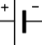 | When more batteries are added to a circuit, the bulb gets brighter.
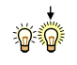 | When a battery with higher voltage is added to a circuit, the bulb gets brighter.
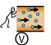 | Too many batteries or batteries with too high a voltage added to a circuit will destroy the bulb.
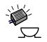 | When more batteries are added to a circuit, the buzzer gets louder, the motor goes faster.
 | When a battery with higher voltage is added to a circuit, the buzzer gets louder, and the motor goes faster.
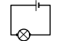 | Wires must be connected to both ends of a battery.
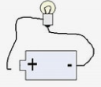 | Breaks in a circuit will prevent it from working.
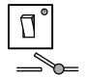 | Switches must be turned on (closed) for a circuit to be complete.
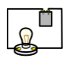 | Circuit diagrams use symbols instead of pictures because symbols are easier to draw.
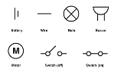 | Symbols provide a universal approach to drawing circuits.


Aspirational Scientist:
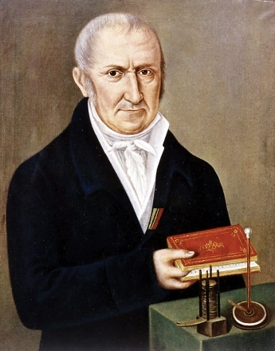
Alessandro Volta was an Italian physicist and chemist who was a pioneer of electricity and power. He is credited as the inventor of the electric battery and the discoverer of methane. He invented the voltaic pile in 1799. With this invention, Volta proved that electricity could be generated chemically and disproved the previous theory that electricity was generated solely by living beings.

Year Six – Electricity

Working Scientifically


