Subject Specific Vocabulary
bacteria | A single-celled micro-organism.
microorganism | An organism that can only be seen using a microscope, e.g. bacteria, mould and yeast.
microscope | A piece of equipment that is used to view very tiny (microscopic) things by magnifying their appearance.
species | A group of animals that can reproduce to produce fertile offspring.
characteristics | Special qualities or appearances that make an individual or group of things different to others.
classify | To sort things into different groups.
taxonomist | A scientist who classifies different living things into categories.
 | Sticky knowledge
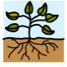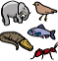 | There are two main groups: plants and animals.
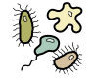 | There are other groups outside of plants and animals, such as microorganisms.
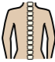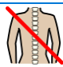 | Animals are divided into 2 groups: vertebrates and invertebrates.  - Some animals have backbones (vertebrates).  - Some animals don’t have backbones (invertebrates).
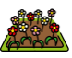  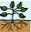 | Plants can be divided into 2 groups: flowering and non-flowering.  - some plants have flowers and some don’t – this means that two more groups can be made for plants (flowering plants and non-flowering plants).  - There are lots of different types of flowering plant, so that you can split them up into more groups.
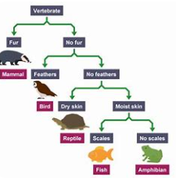 | Branched keys are used to identify plants and animals.
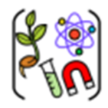

Year Six – Living Things and Their Habitats

Aspirational Scientist:
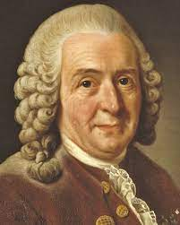
Carol Linnaeus was a Swedish botanist, zoologist, taxonomist, and physician who formalised the modern system of naming organisms. He is known as the "father of modern taxonomy.”
His system (The Linnaean System) classified nature into kingdoms, classes, and species. These were based on shared physical characteristics.

Working Scientifically


