

Year Six – RE: What difference does it make to believe in Ahimsa (harmlessness), grace and/or Ummah (community)?
Subject Specific Vocabulary
Ahimsa | The respect for all living things and avoidance of violence towards others (harmlessness).
harmlessness | The absence of harm.
repent | Feel or express sincere regret or remorse about one's wrongdoing or sin.
Ummah | The whole community of Muslims bound together by ties of religion.
commitment | The state or quality of being dedicated to a cause, activity, etc.
Prophet | A person regarded as an inspired teacher or proclaimer of the will of God (Muslim).

 | Sticky knowledge
 | The ‘big questions’ do not have easy answers and people offer different answers for some of the questions about life, death and suffering.
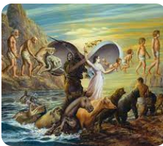 | Christians are committed to believing in God’s grace, or generosity. They think God forgives everyone who truly repents.
 | Muslims are committed to being part of the global ‘Ummah’, the worldwide Muslim family. They stick together; they are one under Allah.
 | Jews believe the Tenakh teaches that suffering can be a test from God, centred around their faith and belief.
 | Hindus believe in karma (beneficial effects come from past beneficial actions) and reincarnation (life after death)
 | Humanists have no belief in the afterlife, but they do believe it is important to live a moral and true life while on Earth.
Key Belief:

It is the practice of people with a religion to believe that the religion is a community to them.

Key Belief:

The tradition of many religions is a belief in a God. In Judaism it is Yahweh. In Christianity is it God. in Islam it is Allah.



Primary and Secondary sources can help us to find out information

