

Year Six – RE: What does religion say to us when life gets hard?
 | Sticky knowledge
 | The ‘big questions’ do not have easy answers and people offer different answers for some of the questions about life, death and suffering.
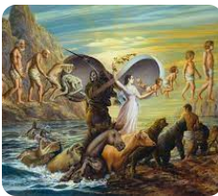 | Christians believe that life after death is a judgement of heaven and salvation through Jesus.
 | Muslims believe that encountering difficult times in life is inevitable.
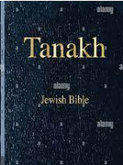 | Jews believe the Tenakh teaches that suffering can be a test from God, centred around their faith and belief.
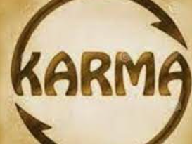 | Hindus believe in karma (beneficial effects come from past beneficial actions) and reincarnation.
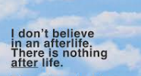 | Humanists have no belief in the afterlife.
Subject Specific Vocabulary
karma | The belief that your actions will determine what happens to you in the current/next life.
reincarnation | The belief in life starting over again based on the behaviours in the previous life.
afterlife | A religious belief in a life after death.
moksha | Escape from the cycle of being- life, death and rebirth that happen as a result of karma.
dharma | Is a person’s duty, the right thing to do in any given situation.
heaven | Where Christians believe they will go after death, if they have led a good life. It is considered a state of being not a physical place.
hell | Where Christians believe they will go after death, if they have lived a bad life. It is the opposite of heaven and is often described as a place of constant fire, pain and suffering.
Day of Judgement | The day (after death) when Christians believe they will face God to be judged on their life.
salvation | Deliverance from sin and its consequences, believed by Christians to be brought about by faith in Christ (Jesus).

Key Belief: 

Hindu's follow the traditional belief of life after death through reincarnation.

Key Belief:
Christians believe that their behaviour and way of living in their current life, will determine whether they go to heaven or hell on their Day of Judgement.

Primary and Secondary sources can help us to find out information


