

Year Six – PSHE: How can the media influence people?
 | Sticky knowledge
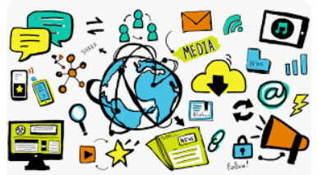 | The media and social media may show images and text that has been manipulated or invented.
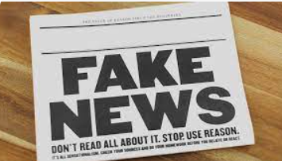 | Fake news or images can be identified by fact-checking what we read or see.  We cannot believe anything we read straight away.
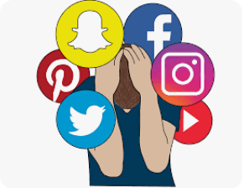 | The media can impact our mental health and well-being positively and negatively, depending on what we see/hear and who we are.
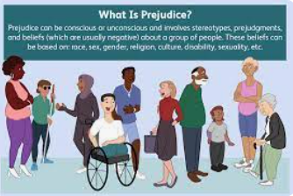 | Prejudice is to judge someone based on their gender, religion, race, sexuality or anything else.
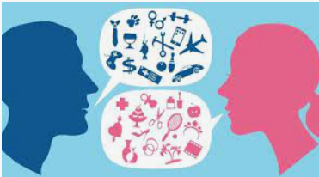 | A stereotype is a fixed idea that many people have about a thing or a group that may often be untrue or only partly true.
 | Gambling has risks including financial, mental, relationships.
 | Money (or the lack of) can cause mental health issues and strains on relationships.
Subject Specific Vocabulary
media | The main means of mass communication (broadcasting, publishing, and the internet).
influence | Being able to have an effect on the character, development, or behaviour of someone or something.
manipulated | Control or influence someone of something cleverly.
reliability | The quality of being trustworthy.
sources | A place, person, or thing from which information comes from.
prejudice | An idea or opinion that is not based on reason or actual experience.
stereotype | An oversimplified image or idea of a particular type of person or thing.
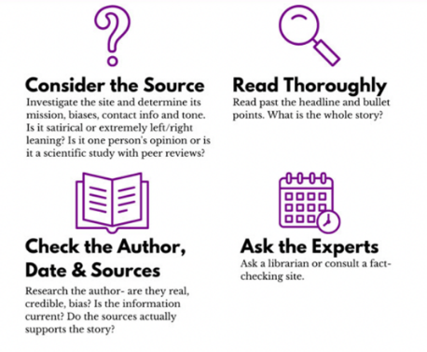

We should always consider and check the reliability of information.


Primary and Secondary sources can help us to find out information

