Subject Specific Vocabulary
tuning | Getting an instrument ready so when it is played it sounds at the correct pitch.
motif | A small collection of notes that captures the idea of the piece.
binary | 2 part musical structure – (AB).
ternary | 3 part musical structure – (ABA).
polyphonic | 2 or more independent melodies played at the same time.
homophonic | One main melody with instruments playing background chords to support.
key root note | The lowest note of a chord.
dynamics | how quietly or loudly a piece of music should be played.
tempo | The speed at which a piece of music is played.
timbre | the quality of a musical note.
 | Sticky knowledge
 | To sing with confidence is to sing so that you can be heard, and show with your facial expression that you are enjoying singing.
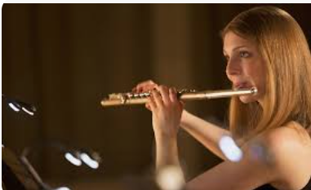 | To sing with accuracy means to get everything in the performance right, including the tuning, timing, dynamics, and words.
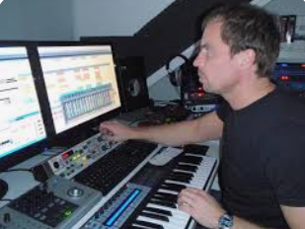 | Technology (a device which can record and play back) can be used to help practise own harmony part.
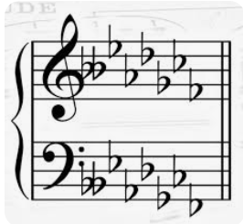 | Each key uses a set of chords based on the notes in its scale.
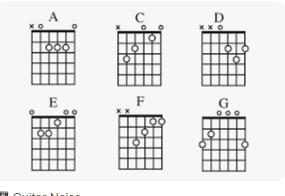 | The pattern to finding a basic chord is to take a note from the scale, and count upwards, missing alternate notes to form the chord (C, E, G).
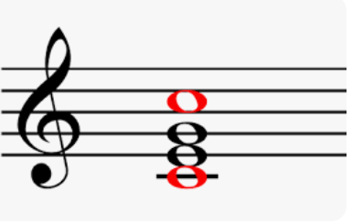 | The lowest note of the chord is called the root note.
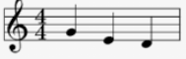 | A motif can represent a character in the piece.  Sudden change in dynamics can evoke emotions.
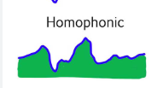 | Pop music often uses homophonic textures, such as a melody accompanied by chords. Common structures used in pop music include verse chorus structure.
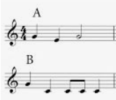 | Classical music often uses polyphonic textures. Common structures used in classical music include binary (AB) and ternary (ABA) form.
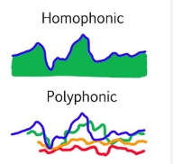 | Texture can be polyphonic – with many layers all moving independently – homophonic – with many layers moving in time as chords – or unison – with only one layer.
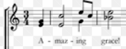 | Music can be ‘through-composed’ – in one long section – or broken up into different sections to give it more structure.
 | Composers use devices such as ostinato, motif, chord progressions, sequence, syncopation and pedal notes to help structure and add interest to their music.
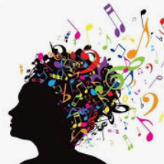 | An improvisation can be free, or based on a particular musical device such as a chord sequence, rhythmic or melodic cell.
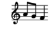

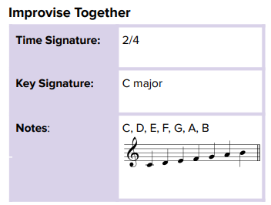
Year Six – Music: How does music connect us with our past?

