Subject Specific Vocabulary
competence | Having the necessary ability, knowledge, or skill to do something successfully.
confidence | Believing in yourself and your own abilities.
self-rescue | The ability to safely get out of trouble in water by staying calm, floating, and getting to safety on their own.
survival | Having the essential skills to survive a fall into water, knowing how to float, control breathing and swim to safety.
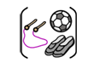

Year Six – PE – Indoor: Swimming and Health Related Exercise

 | Sticky knowledge
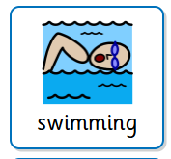 | Perform an accurate and consistent stroke on the front and back when swimming 25m.
 | Face in the water, breathing to the side, alternating arm strokes, legs straight.
 | Hands used to pull the water to help efficiency.
 | Leg kicks create small splash to improve effectiveness.
 | Personal survival stroke is where the arms remain underneath the water, especially if clothed, as this is easier than being above the water and will help to safe energy.

 | Sticky knowledge
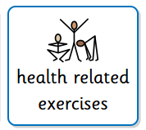 | Exercise contributes to physical wellbeing.  Exercise contributes to mental wellbeing.
Being active in school includes: PE lessons, being active in class, staying active at break and lunch times.
Being active outside school can include active travel, extracurricular activities, external clubs at home in organised or recreational play.

Speed and power athletics require more fast-twitch fibres.
Endurance athletes require good stamina.
Training effects performance.
Physique influences attributes of athletes.

A personal best is their own highest result obtained in an event for example: time, distance, height.
Results and personal bests are identified by: measuring and marking, using appropriate equipment, time-keeping (stop-watch), distance (tape measures), observing, recording, comparing and analysing results.

Subject Specific Vocabulary
personal best | The best time or score ever achieved by a sports player in a particular event.
self-reflection | Thinking about what you do, how you feel, and why you do things.
drive | A strong internal motivation, determination, and energy to achieve a goal.
endurance | The ability of the body to perform physical activity for a sustained period.
physique | The structure of a person’s body.
physical wellbeing | Being healthy and strong by taking care of your body.
mental wellbeing | How you feel, think, and act, which affects your emotional, psychological, and social health.



