
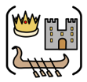
Year Six – History: Does your circumstance determine your destiny?
Subject Specific Vocabulary
Queen Victoria | Was the Queen that the Victorian era was named after. She was the longest reigning monarch until Queen Elizabeth II.
monarch | A head of state, especially a king, queen, or emperor.
Industrial Revolution | The process of change from farming the land to industry and machine manufacturing.
empire | A group of states or countries ruled over by a single monarch.
act | Approved by the government and the monarch, acts of Parliament make up the Law in the UK.
exhibition | A public display of works of art or items of interest.
rural | The countryside rather than the town.
poverty | Being extremely poor.
wealth | Being extremely rich.
circumstance | A condition, fact or event in which a situation the way it is.
destiny | The events that will happen to a particular person or thing in the future.
legacy | The long-lasting impact of events or actions of a person’s life.
census | an official count or survey, of a population.

 | Sticky knowledge
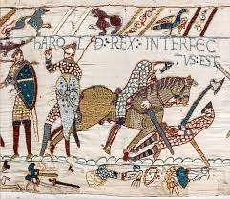 | - Norman Conquest (1066): William the Conqueror invaded England and defeated the last Anglo-Saxon king of England, at the Battle of Hastings.  - Medieval Period saw the consolidation of Norman rule. The Magna Carta, a charter of rights and liberties, was signed in 1215.  - The Tudor dynasty, included monarchs like Henry VIII, and marked a period of political and religious change in Britain.  - The English Civil War was a major conflict between Parliamentarians and Royalists that led to the establishment of the Commonwealth of England.  - The Industrial Revolution is a period of significant technological advancements and economic growth.  - The British Empire brought about significant changes in British foreign policy and Britain's global influence expanded.  - World Wars and Post-War Era: Britain played a pivotal role in both World War I and World War II, The post-war era saw the decline of the British Empire. Modern Era: In the post-World War II period, Britain underwent significant social and cultural changes, including the rise of the welfare state, the growth of the National Health Service, the expansion of higher education, and increased cultural diversity.
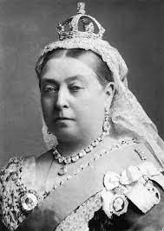 | Queen Victoria was the monarch of Britain from 1837-1901. She was the first member of the Royal Family to live in Buckingham Palace as we know it today. She was the longest reigning monarch, until Queen Elizabeth II. She made many changes during her reign to make Britain better. She married her cousin, Albert and had 9 children; he died young, and she mourned his death for the rest of her life. When she died in 1901, at the age of 81, the Victorian era ended. Queen Victoria left a lasting-legacy of: making school compulsory for all children no matter their wealth; the Industrial Revolution; bridging the gap between rich and poor; skilled labour; technology; housing; transport.
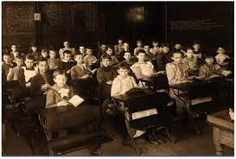 | Education was made compulsory during QV’s reign. Before this, children had to pay to go to school. At school, learning was focused around the 3 Rs. Boys and girls were split. Books were in short supply, and slate was used. Children were punished for not being punctual, correct, well-behaved, with the cane and dunce hat.
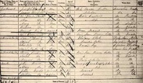 | A census is taken every 10 years, in years ending with a 1. It gathers information about who lives where, their ages and occupations. We can learn information from the past about the people who lived in these years.
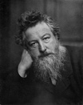 | William Morris was an artist in Victorian times famous for creating art-work based upon nature. He created fabrics and wallpaper which Victorians wanted for their homes in the busy cities, as it reminded them of being in the countryside. He created his pieces of art using printing to build a pattern/image.
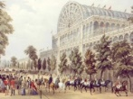 | The Great Exhibition was the world's first international exhibition of manufactured products, held in the Crystal Palace in London. It showcased the latest technological advancements of the time, including the telegraph, steam engines, and other innovations. The exhibition was seen as a symbol of British industrial and economic power. The Great Exhibition was a turning point in the history of the Victorian era and marked the beginning of a new era of technological progress and globalization. It had a significant impact on the British economy, as it led to increased trade and investment from other countries.
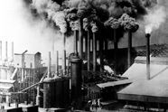 | The industrial revolution was between 1760-1840. An industrial revolution is caused by 6 things: population boom, transportation, agricultural technology, power, Empire, factories. It changed the way Britain worked. The Industrial Revolution was a significant event in the history of the UK, which transformed the country from an agricultural-based economy to a manufacturing-based economy. The increased productivity and economic growth brought about by the Industrial Revolution had profound effects on society, including changes in working conditions, urbanization, and social class divisions.
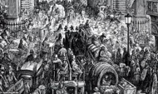 | One consequence of the Industrial Revolution was the rise of the middle class. The rapid industrialization and urbanization also led to poor working conditions, overcrowded cities, and environmental degradation, which resulted in various social problems, including poverty, disease, and crime. These issues, in turn, led to social reform movements and political changes that addressed the consequences of the Industrial Revolution. For example, the working-class movement and the formation of labour unions were a response to the poor working conditions and exploitation of workers in factories. The public health movement was a response to the spread of disease in overcrowded cities, and the education movement was a response to the need to educate the growing population.
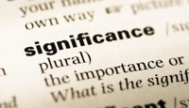 | Different people can decide that different things are significant, or that they can disagree about the reasons a particular person, event, place or idea is important. Significance is not the same to everyone, or at all times in history. What we consider to be important can change. Some events which were considered significant a century ago may not be important to us now.
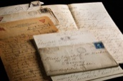 | Sources are considered when asking and answering questions about the past. A primary source (also called an original source) is an artifact, document, diary, manuscript, autobiography, recording, or any other source of information that was created at the time under study. It serves as an original source of information about the period/event/person. A secondary source is a document or recording that relates or discusses information originally presented elsewhere. Sources can be linked through elements such as author and time of creation.
 | Different versions of events are always possible as people remember events differently. Memories of the same event often differ due to fading or outside influence. Historical accuracy is based on the assessment of sources.
Exciting texts!

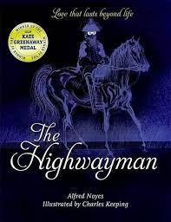
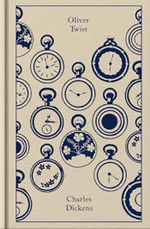
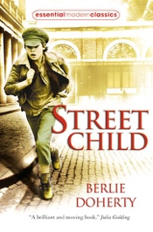


 Enhancer Sticky Knowledge:
Proportion is an element of art that compares the size of part of an object in relation to the size of another part of the same object. Perspective is the art of representing 3D objects on a 2D surface. Depth is the apparent distance from the foreground to the background, or near to far, in a work of art.
To over print is a simple or complex pattern that’s repeated using line, shape or tone. It is the process of printing one colour on top of the other. It can be layering of text or images on different backgrounds.


