
Year Six – MFL: At School
 | Sticky knowledge
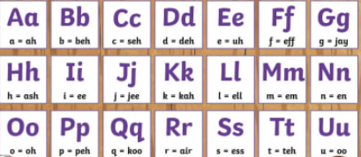 | Follow a short, familiar text, reading and listening at the same time.  Read familiar words, phrases and short sentences aloud with good pronunciation and apply phonic knowledge when reading aloud.
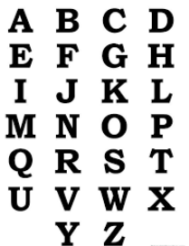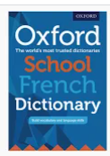 | Use alphabetical order to find meanings.
 | Know which part of a paperback bi-lingual dictionary to use to find the information required (front half or back half).  Use a dictionary to find gender, word type and uses of words.
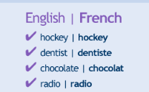 | Use cognates and familiar language to work out the context of a poem.  Use these clues to work out unfamiliar language in TL confidently.
 | Know how to use all this information to change a sentence correctly.
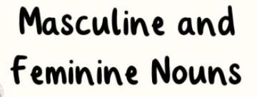 | Writing reflects understanding of gender of nouns, forming the plural, word order and agreement of high frequency adjectives.  Writing may also show some understanding of past and future tense.
Subject Specific Vocabulary
à l'école | School
le français | French
l'anglais | English
le dessin | Art
le sport | PE
la musique | Music
la géographie | Geography
l'histoire | History
les maths | Maths
les sciences | Science
l'informatique | ICT
Quelle heure est-il ? | What time is it?
Il est ---- heures. | It is ---- o’clock
J'étudie + (subject) + à + (number) + heures. | I study (subject) at (number) o'clock.


