

Year Six – Computing – Coding
 | Sticky knowledge
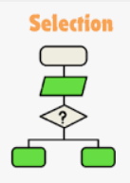 | Selection is a programming construct where a section of code is run only if a condition is met.
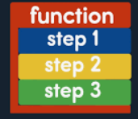 | Function is a type of variable.
11 +13 | Number variable can be used in a sum.
ABCDE | Text variable is letters.
11 ABC 123 | String variable is a combination of numbers and text.
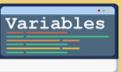 | Variables can develop code (e.g. timers and score counters using conditional statements e.g. if the timer reaches 0, the game ends).
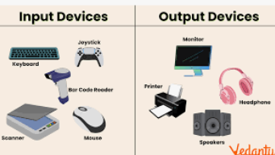 | Inputs can be specific keys or combinations.  Outputs can be on-screen or external.
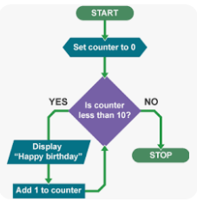 | Repetition is lines of code will be run multiple times.  Count controlled repetition is when the number of repetitions is known.  Forever repetition will run and keep repeating itself the whole time a program is active.  Nested repetition is where two or more repeating statements are placed in a "nested" form, i.e., one repetition is situated within the body of the other.
 | Repetition and variables together make a developed efficient program.
 | Variables make a change in a program.
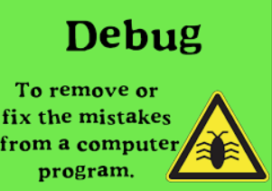 | Splitting a program down into smaller parts allows you to spot errors and debug more efficiently.
Subject Specific Vocabulary
selection (If, Then, Else) | Helps the computer decide what to do next.
variable | A labelled box in a computer that holds a piece of information, such as a number or a name.
repetition | Lines of code that run multiple times.
count controlled | The number of repetitions is known.
nested repetition | Two or more repeating statements are placed in a "nested" form, i.e., one repetition is situated within the body of the other.
forever | Always.
decomposing | Breaking a big, complicated problem into smaller, simpler parts that are easier to solve one by one.



