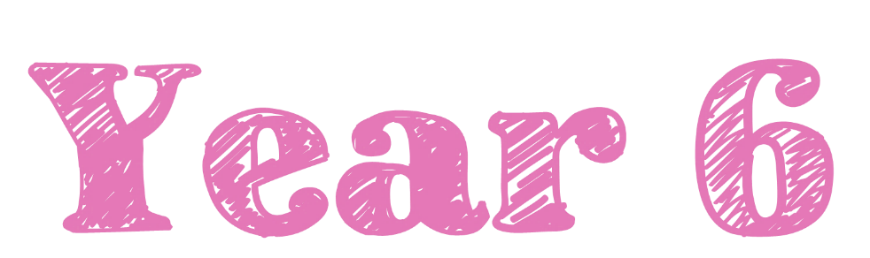  Spring Term 2026 |  | 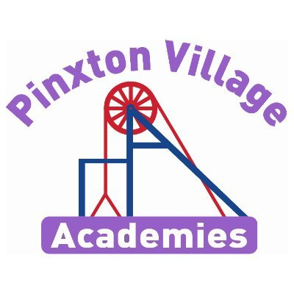
Welcome to Year 6!

Welcome back and welcome to 2025! We hope you have all had a super Christmas break and are feeling well rested and ready for a busy term full of lots more learning!

As a reminder, healthy snacks (such as fruit or cereal bars) are allowed in school for break times.
If you have any concerns, please don’t hesitate to come and talk to us.

Miss Bentley and Miss Oakley

Reading Diaries and Books  Your child will regularly read their book in class and we will look at their diaries every week.  PLEASE make sure your child brings their book and diary to school every day. Please read with your child every day and sign their diary to show this. It is incredibly important that you list to your child read every day. If you would like support with listening to your child read at home, please speak to Miss Bentley or Miss Oakley  Children will receive a reading book at the start of this term. We will assess them on these books regularly to make sure they have the right book for them. If you are worried that these books are too easy or too challenging, please speak to your child’s teacher. | PE Kits  On PE days, children will need to come to school in their PE kits. Children will be unable to join in with PE lessons, if they are not wearing their kit.  On PE days, please make sure earrings are removed and hair is tied up.  Miss Bentley’s PE days will be Mondays and Fridays  Miss Oakley’s PE days will be Mondays and Fridays  Please make sure footwear is appropriate for running around and that you don’t mind if they get muddy and wet. Inhalers must be in school on these days too.
Important Dates | Homework  Children are expected to read and practise their times tables (on TT Rockstars) daily.  TT logins can be found in the back of your child’s home school diary  SATS revision books for maths, reading, grammar, spelling and punctuation will be given out the 1st week in January. We expect the children to complete at least a page a week in each book. We will collect the books in on a regular basis to check your child is on top of their revision / homework and to support where necessary. All of the books need to be completed by the end of May.
  Event | Dates
  Victorian Afternoon | Friday 9th January
  Swimming | 5th to 23rd January
  Aspiration day | Monday 26th Jan
  Parent’s evening | Tuesday 3rd and Wed 4th Feb
  Safer Internet Day | Thursday 10th Feb
  Junior Disco | Wednesday 11th Feb
  INSET DAY | Monday 23rd Feb
  World Book Day / Cake sale | Thursday 5th March
  INSET DAY | Friday 27th March

Follow us on social media, where we showcase our wonderful school and learning experiences.

Does your circumstance determine your destiny?
This term, our enquiry focusses on the history of the Victorians. In particular, we will be looking at the difference between the lives of the rich and the poor, alongside the legacy of Queen Victoria and the Industrial Revolution. Our Hook Day – the trip to Perlethorpe, will immerse children in the enquiry from the first day, sparking an enjoyment for the topic. We will learn a lot of new history alongside art inspired by the Victorian block-printer William Morris. All of our learning this term, is presented in the knowledge organiser on the next page.
Deepening Knowledge Tasks

Reading  Reading is the gateway to the curriculum. We will be reading and learning all about the text Oliver by Charles Dickens, and will read Street Child by Berlie Doherty at the end of the day. In lessons, we are focusing on the skills of reading to understand the whole text and retrieving information from the text.  When you read with your child, please ask them questions about what they have read so they can demonstrate their understanding.  CHAPTER 1 - STREET CHILD by Berlie Doherty - YouTube  "Oliver Twist" by Charles Dickens, Chapter 1 (story read by Tom O'Bedlam) - YouTube | Writing  This term we will be writing a historical narrative based on the story Oliver, which is the class book that we will be studying in our reading lessons. We will also be writing based on Oliver’s experiences and writing a balanced argument to answer our enquiry question.  To prepare even more, perhaps you could begin to research life as a Victorian child, particularly a poor one. This will help you to understand life as a poor Victorian child and the historical details of the time period  Victorian Era For Kids // 19th Century Everyday Life - YouTube  The Victorians - BBC Bitesize |  | Maths  We follow the White Rose scheme in Maths. Follow the link below and you can follow lesson by lesson what your child is learning in school.  https://whiterosemaths.com/homelearning/year-6/ Spring  This is a great resource to support your child and for you to see how we teach maths.  Below are some websites to support with SATS revision  KS2 Maths - BBC Bitesize  Y6 Arithmetic Practice - Mathsframe
Science

In science, our focus will be physics and we will be learning about electricity.
This will cover the history of electricity (including the invention of the battery, light bulb etc), key discoveries and creating circuits. To develop your learning at home, could you set up an experiment looking at how changing components in a circuit affects the brightness of a bulb.
Our second unit of the term will be biology and looking at classification of living things and microorganisms

Further support for science can be found here: https://classroom.thenational.academy/units/electrical-circuits-06f7
What is a microorganism? - BBC Bitesize

RE  We follow the Derbyshire Syllabus. This term, we will be learning around the questions:  - What does religion say when life gets hard?  - What difference does it make to believe in Ahimsa, Grace and or Umah?  One Ummah - YouTube |  | PSHE  We teach PSHE through the PSHE Association. This term we will be focusing on the question: How can the media influence people?  What Is Media? | Kids Videos - YouTube  Social Media: Why do we like getting likes? | Newsround - YouTube
Computing  We teach Computing through Purple Mash. This term we will be learning about coding. We will also keep revisiting how to stay safe online. The following links maybe helpful  https://school-learningzone.co.uk/key_stage_two/ks2_computing/ks2_e_safety_for_kids.html  https://www.saferinternet.org.uk/advice-centre/young-people/resources-3-11s  https://www.nspcc.org.uk/keeping-children-safe/online-safety/ |  | PE  In PE, there will be a variety of indoor and outdoor sports, including Swimming, Health Related Exercise, Hockey, Tag Rugby.  ALL ABOUT HOCKEY || Learn Hockey Facts || Sports education video for Kids || - YouTube  Tag Rugby - An Introduction - YouTube



