
Year One – PE: Spring 1
 | Sticky knowledge
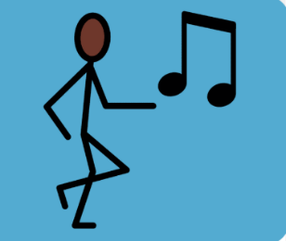 | Dance: Zoo  To be a champion dancer, you have to time your dance with the beat of the music.
 | Movements in dance are big, clear and purposeful.
 | Dancing in a sequence means we combine different movements.
 | Dancing with expression means we project our thoughts and feelings with our bodies.
 | In dance, we move with control and respond to the rhythm and beat.
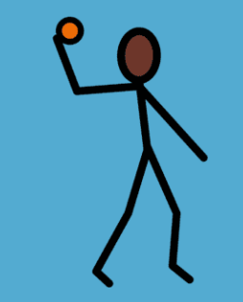 | Ball skills: hands  When throwing the ball, use overarm and underarm to throw accurately and to beat your opponent.
 | Throwing the ball and aiming accurately is a skill that takes lots of practice. Catching is also a skill and requires hand eye coordination.
 | When playing in a game, we must listen, play by the rules and work together in our teams.
Subject Specific Vocabulary
Champion dancer | Moving with control, responding to rhythm in relation to the music.
Beat | Dancing to the notes of music in time.
Moving | Using body parts in a creative way
Control | Moving bodies in time with the music, beat or sound.
Motif | Movements that are repeated.
Rhythm | Repeated patterns of movements or sounds.
Sequence | Movements added together.
Expression | Dancing to show feelings and thoughts.

Subject Specific Vocabulary
Overarm | Throwing a ball by raising your arm over your head.
Underarm | Throwing a ball by lowering your arm.
Throwing | Using your hand to propel the ball.
Accurately | Consistently aiming the ball well.
Teamwork | Working together with your teammates.
Catching | Holding out hands to grab the ball.
Batting | Skill of hitting the ball with a bat.
Attacker | Someone who has possession of the ball
Defender | Not in possession of the ball.

