
Year One – PE: Spring 2
 | Sticky knowledge
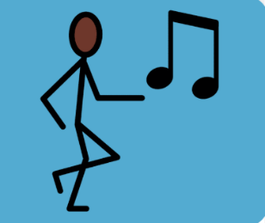 | Dance: growing  To be a champion dancer, you have to time your dance with the beat of the music.
 | Movements in dance are big, clear and purposeful.
 | Dancing in a sequence means we combine different movements.
 | Dancing with expression means we project our thoughts and feelings with our bodies.
 | In dance, we move with control and respond to the rhythm and beat.
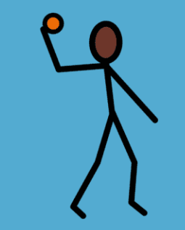 | Ball skills: feet  In order to keep control of the ball, we need to move carefully when dribbling.
 | To accurately pass the ball, we need to communicate with our teammates to prevent defenders from stealing the ball.
 | When moving with the ball, we need to think about the speed and how fast we are travelling to not let defenders steal the ball.
Subject Specific Vocabulary
Champion dancer | Moving with control, responding to rhythm in relation to the music.
Beat | Dancing to the notes of music in time.
Moving | Using body parts in a creative way
Control | Moving bodies in time with the music, beat or sound.
Motif | Movements that are repeated.
Rhythm | Repeated patterns of movements or sounds.
Sequence | Movements added together.
Expression | Dancing to show feelings and thoughts.

Subject Specific Vocabulary
space | A space that is free without attackers or defenders.
dribbling | A method of moving with the ball.
Passing | A method of sending the ball to another member of the team.
control | Keeping the ball close to you to prevent a defender from gaining possession.
Teamwork | Working together with your teammates.
Attacker | A person who is in possession of the ball.
Defender | A person who is not in possession of the ball.

