

PSHE Year one
 | Sticky knowledge
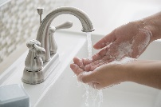   | I can stay healthy by washing my hands and exercising.
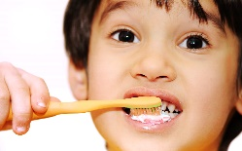 | Brushing our teeth and visiting the dentist regularly keeps our teeth healthy.
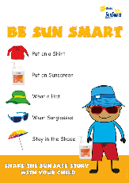 | Wearing a hat, applying suncream and spending time in the shade helps us stay safe in the sun.
 | I know there are different feelings and I know how these feelings can affect my behaviour.
 | I know people can say hurtful things online and I know I should tell a trusted adult if this happens.
Subject Specific Vocabulary
sun safety | Ways to stay safe in the sun and protect yourself from getting burnt.
feelings | An emotional state or reaction.
healthy | In a good physical and mental condition.
behaviour | The way someone acts.
dentist | A person who checks your teeth and gums.
online | Available on or performed through using the internet.
hurtful | Something to upset someone else’s feelings.
bodies | The main section - a combination of body parts.
exercise | Keeping the body healthy by being active.

