

Year One – RE: What does it mean to belong to a faith community?
 | Sticky knowledge
 | A community is a group of people that have a certain thing in common.
 | The symbols that show that a Christian belongs to the Christian faith include cross and fish.
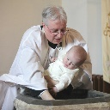 | Christians reinforce their feeling of belonging to their faith e.g. christening and baptism.
 | The story of Jesus getting baptised in the River Jordan is an important story to Christians and carries messages about belonging.
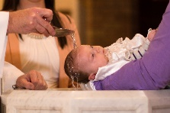 | Christians believe everyone is valuable and they showed this to the infant baptism.
 | Weddings are a way in which Christians show they belong to each other and make a promise to God.
 | Different religious communities work together to do charity work.
Subject Specific Vocabulary
Golden Rule | Treating other people as you would like to be treated.
belonging | To feel happy in a place or situation.
worship | An act that shows your love for God.
holiness | Being holy.
community | A group of people living in a particular area, who have things in common.
sacred | Connected with God.
faith | To have trust in God.
religion | The worship of God.
support | Giving help to those who need it.
loyalty | Faithfulness or attachment to someone or something.


Key Belief:
Christians hold infant baptisms to show that everyone is valued.
Key Belief:
Christians must follow the Golden Rule in their religion.



