
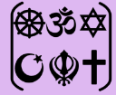
Year One – RE: How and why do we celebrate sacred times?
 | Sticky knowledge
 | Christian festivals include Christmas, Easter and Harvest.
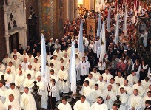 | People celebrate in different ways including singing songs, ways of worship, stories, artefacts and eating special food associated with these celebrations.
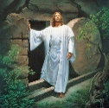 | Christians believe Jesus’ body was resurrected, meaning that there is eternal life after death.
 | On Palm Sunday, Christians wave palm branches to remember Jesus' arrival.
 | On Maundy Thursday, Christians ate bread and drank wine to remember Jesus’ last supper.
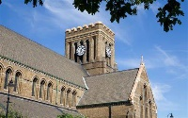 | On Good Friday, Christians attend Church and fast from some foods.
 | On Easter Sunday, Christians break Easter eggs to symbolize the empty tomb.
Subject Specific Vocabulary
Christmas | A Christian holiday to celebrate the birth of Jesus.
Easter | A Christian holiday celebrating the resurrection of Jesus.
Harvest | The celebration of the food that has been grown on God's land.
community | A group of people living in a particular area, who have things in common.
sacred | Connected with God.
faith | To have trust in God.
religion | The worship of God.
loyalty | Faithfulness or attachment to someone or something.
resurrection | Bringing someone back to life after they have died.

Key Belief:
Easter is celebrated over 4 days. The days are Palm Sunday, Maundy Thursday, Good Friday and Easter Sunday.
Key Belief:
Christians have different festivals to remember the different parts of Jesus life.



