 | Sticky knowledge
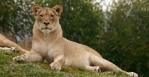 | A - A vertebrate is any animal that has a backbone.
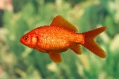 | B- Fish have scales, breathe with gills, live in water and are cold blooded.
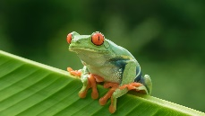 | C- Amphibians breathe with lungs and are cold blooded with smooth skin.
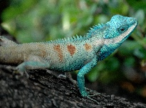 | D- Reptiles have dry scaly skin, breathe with lungs and are cold blooded.
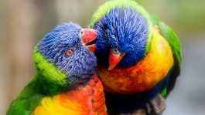 | E- Birds have feathers and wings, are warm blooded and breathe with lungs.
 | F- Mammals have hair, are warm blooded and breathe with lungs.
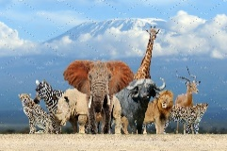 | G- Animals can be put into groups. Differences and similarities can be used to group animals.
 | H- Winter changes to Spring where new buds grow, days get lighter and the weather includes more rain. Spring months are March, April and May.
 | I - Things start to grow, plants are more colourful in Spring, the weather gets warmer, the days get longer, and the nights get shorter.


Year one –animals including humans
Subject Specific Vocabulary
vertebrate | A living thing that has a backbone.
invertebrate | A living thing that doesn’t have a backbone.
amphibians | An amphibian is a cold-blooded vertebrate.
reptiles | A reptile is a vertebrate that has scaly skin.
classifying | Classifying is when living things are sorted into groups based on their characteristics.
temperature | Temperature is how hot or cold something is.
Aspirational Scientist:

Hamza Yassin is a wildlife camera man. He studied zoology, conservation and biological photography at university. He has appeared on several television programmes including – Ranger Hamza on CBeebies, Animal Park and Countryfile.


Primary and Secondary sources can help us to find out information

