
Year one – materials
 | Sticky knowledge
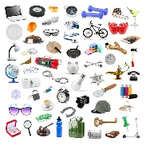 | An object is something made from any material that can be seen or touched. For example, a table is an object, the material it is made from is typically wood. A window is an object, the material it is made from is glass/plastic/wood.
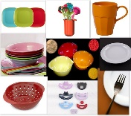 | Everyday materials are the materials that most objects are made from E.G. wood, plastic, glass, stone and metal.
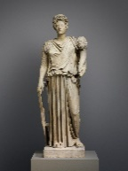 | Statues and sculptures can be made from rock/stone.
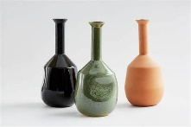 | Vases and cups are objects that can be made from clay.
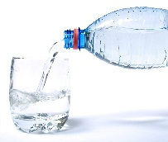 | Drinks can be made using water (e.g. tea and squash).
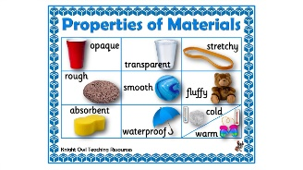 | A property of a material is a characteristic that we can measure, see or feel.
 | Some materials can have the same properties AND different properties. E.g. Metal and glass are both hard. Metal is opaque but glass is transparent.
Subject Specific Vocabulary
material | What an object is made from.
transparent | Light can pass through so that objects placed behind can be seen.
opaque | Light cannot pass through, objects behind cannot be seen.
fragile | Can be broken easily.
waterproof | Keeps water out.
stiff | Not easily bent or changed shape.
property | The characteristics of an object.
elastic | When an object can be stretched and changed shape, but it will return back to its normal shape.
Aspirational Scientist:

Alexander Parkes was an English chemist. He invented the first plastic which was known as Parkesine. He is sometimes called the grandfather of plastic. He inspired many other scientists to develop new plastic products.

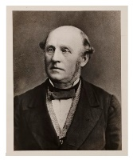
Primary and Secondary sources can help us to find out information

