 | Sticky knowledge
 | The past has happened previously; the present is happening now.
 | Chris Wheatley received an OBE for his services to education. He is the CEO of the Flying High Partnership. This means he is the leader.
 | Dr. Sarah Gilbert was part of developing the Covid-19 vaccine. She trained at Oxford University and created the Astra-Zeneca vaccine.
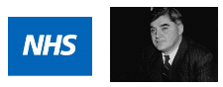 | The NHS was set up by Aneurin Bevan in 1918. It gave free medical care to people in the UK for the first time. There have been changes in technology and medicine ever since.
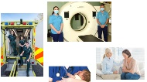 | There are now lots of different jobs in medicine that didn't exist 100 years ago. These include paramedics, radiographers, midwives and mental health practitioners.
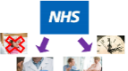 | Because of the NHS, we are living longer, and infectious diseases have reduced.
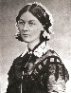 | Florence Nightingale was born in 1820, in Italy. She worked as a nurse in the Crimean war and improved nursing and hospitals internationally.
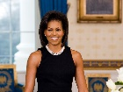 | Michelle Obama was the first African American first lady who made lots of positive change. She launched ‘Let’s move’ during Covid-19 to end child obesity, advocated poverty awareness and launched the ‘Let Girls Learn’ initiative.
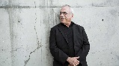 | Rob Janoff designed the Apple logo which is now recognised worldwide. Over the years he created many different Apple logos starting with the first one in 1976 right up to the present.
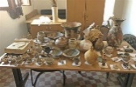 | Artefacts give us information about the past. They are man-made objects and can include tools, art and clothing.
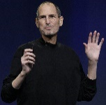 | Steve Jobs formed the Apple company and was one of the founders of Pixar. He has changed the way that we communicate and learn. His artefacts show how technology has changed over time.
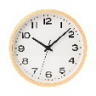 | Chronology shows time order that events happen in.
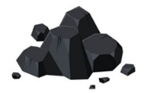

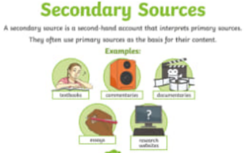
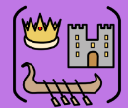
Year One – History: Can one person really change the world?
Subject Specific Vocabulary
chronology | The order of dates or events.
past | Something that happened previously.
present | Something that is happening right now.
previously | At an earlier time.
OBE | An award given for a special achievement.
CEO | The leader of a place.
Covid-19 | An infectious diseases caused by a virus.
internationally | Something that involves more than one country.
worldwide | All around the world.
infectious diseases | An illness caused by germs that spreads from one person to another.
man-made | Made by human beings.
different | Not the same.
significant | Very important.
Crimean war | A war that happened in the 1850’s.
pandemic | When an infectious disease affects the whole world.

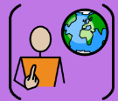
David Attenborough is a naturalist and broadcaster. He has made many programmes for television about wildlife all over the world.

Texture is all around us and some is manmade and some is natural.
A line is a dot that you can take for a walk. They can be continuous or broken. They can be straight, curved, horizontal, vertical or diagonal.
Shapes can be geometric or organic.
A sharp pencil can create a thin line but a blunt pencil or a pencil at an angle can create thicker lines.
A pattern uses a repeated design or motif created using line, shape, colour or tone.

Sticky Knowledge

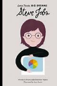
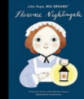
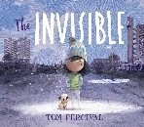
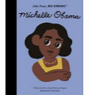
Exciting texts!
Primary and Secondary sources can help us to find out information

