

Year Five – RE: If God is everywhere, why go to a place of worship?
 | Sticky knowledge
 | A place of worship helps believers’ worship.
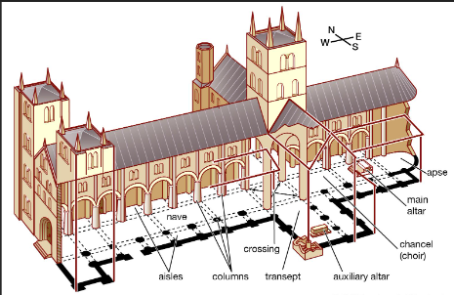 | Different churches have different features e.g. a font vs a pool for baptism or an organ vs a band for music.
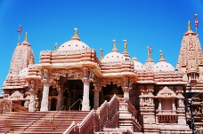 | A mandir is a Hindu temple, which is a place of the gods, (meaning ‘dwelling place’ in Sanskrit).
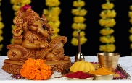 | A murti is an image, statue, or carving that represents a Hindu god, and during puja—the Hindu act of worship—believers hold that the spirit of the god enters the image.
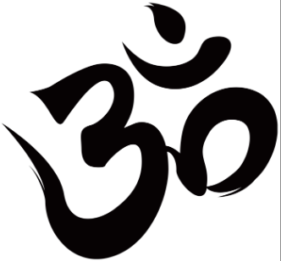 | Om is the Hindu symbol: the sound of God. Hindus say when they worship or meditate to bring their minds to God.
Subject Specific Vocabulary
Anglican | Someone who practises/worships within the Church of England.
Baptist | Baptist, a member of a protestant Church who believe that only believers can be baptised and it should be done by immersion rather than sprinkling water over the head.
murti | A murti is a representation of a God being worshipped. It is usually made from stone, metal or wood.
om | A sacred sound or syllable.
mandir | A place where Hindus go to worship. It means dwelling place in Sanskirt.
synagogue | Also known as a temple, it is a place of worship and teaching for Jews.
symbol | A symbol stands for something which is linked to an idea, object or relationship.
Key Belief:
Hindus believe there is one supreme God who is represented in many different forms. Many Hindus worship at home and have a special shrine dedicated to certain gods and goddesses.

Key Belief:
Christians believe there is only one God. They feel closer to God in a place of worship.





Primary and Secondary sources can help us to find out information

