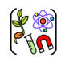

Year Five – Earth and Space
 | Sticky knowledge
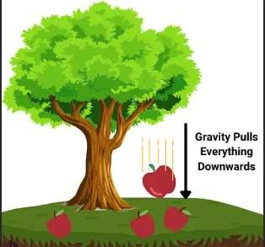 | Gravity pulls objects towards the centre of the Earth.
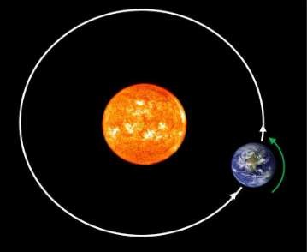 | The Earth takes 365 and a quarter day to go around the Sun. Four quarters make one extra day, so every four years we add a day — this is a leap year
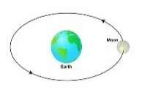 | It takes about 28 days for the Moon to orbit the Earth.
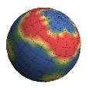 | The Sun, the Earth and the Moon are approximately spherical.
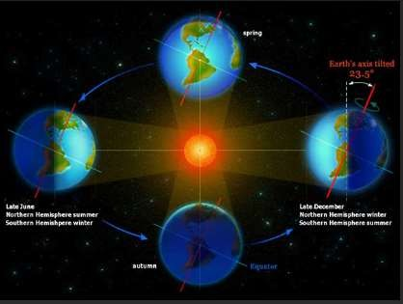 | The Earth takes 24 hours to completely rotate (spin) on its axis. (24 hrs = 1 Day)
Subject Specific Vocabulary
gravity | The force which pulls things to the centre of Earth. Gravity also holds Earth and other planets around the sun.
force | Forces are pushes and pulls in certain directions.
gradational | Changes over a gradual time.
gravitational | A movement towards the centre of gravity.
solar system | Contains one star (sun), eight planets:  Mercury, Venus, Earth, Mars, Jupiter, Saturn, Uranus, and Neptune; dwarf planets Pluto, Ceres. All the planets are drawn towards the sun by a gravitational force.
spherical | Shaped like a sphere (a round object).
axis | An imaginary line which the Earth rotates (turns).
Aspirational scientist:
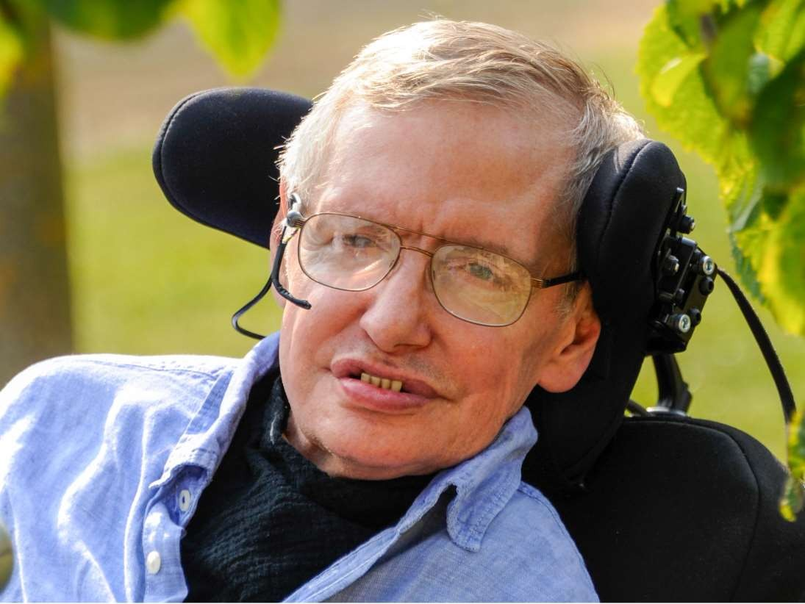
Stephen Hawkings, who was a world famous scientist, is renowned for his work on space and cosmology (the Science of the Universe). He was born on 8th January 1942 and died on 14th March 2018.
Working scientifically
 Observation 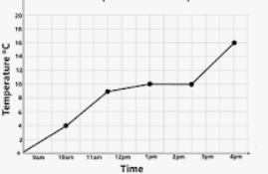 Recording
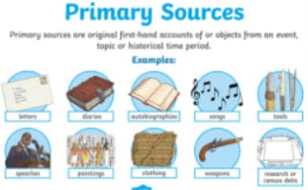
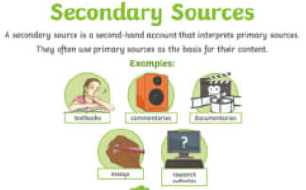
Primary and Secondary sources can help us to find out information

