

Aspirational Scientist:
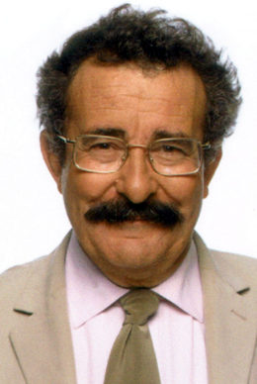
Robert Winston is a British professor, medical doctor, scientist, television presenter. In the 1970s he developed gynecological surgical techniques that improved fertility treatments.
Year Five – Animals including humans
 | Sticky knowledge
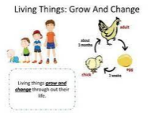 | All living things go through changes during their lifetimes.
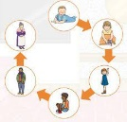 | Humans go through a life cycle of : Fertilised egg – foetus – baby – child – adolescent – adult – old age – death.
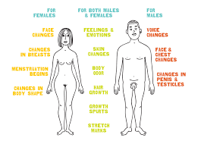 | Puberty is when the body develops; the bodies of boys and girls change.
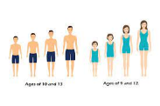 | Puberty happens during adolescence (between 10 and 18 years old).
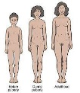 | Girls  - hair starts to grow on their bodies.  - breasts develop and hips widen. Ovaries start to release an egg once a month.  - This is when periods begin.
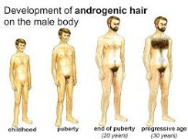 | Boys  - Hair starts to grow on their bodies Hair also starts to grow on their faces.  - Testicles start producing sperm.
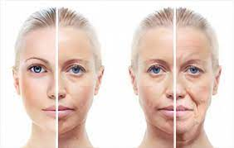 | As we get older, our bodies continue to change. Skin loses is elastin, hair turns grey or falls out and some of our senses become less sharp.
Subject Specific Vocabulary
fertilisation | The process of male and female sex cells fusing together.
foetus | An offspring of a human or other mammal in the stages of prenatal development that follow the embryo stage.
adolescence | The social and emotional stage of development between childhood and adulthood.
puberty | The physical stage of development between childhood and adulthood.
ovaries | A female reproductive organ in which eggs are produced.
menstruation | When the female body discharges the lining of the uterus. This happens approximately once every month.
testicles | Either of the two oval organs that produce sperm in men.
sperm | A sex cell produced by a male.

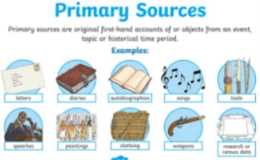
Primary and Secondary sources can help us to find out information

