Subject Specific Vocabulary
spoof | When someone pretends to be someone or something else on a computer or the internet to trick people.
spam | Sending massive amounts of electronic junk mail that people haven't asked for.
trustworthy | A computer, app, or website can be trusted to work safely, correctly, and fairly.
malware | A file or code, typically delivered over a network, that infects, explores, steals or conducts virtually any behaviour an attacker wants.
spyware | Malicious software designed to enter your computer device, gather data about you, and forward it to a third-party without your consent.
pop-up | Forms of online advertising on the World Wide Web.
graphical User Interface (GUI) | Usually a small window, that suddenly appears
blog | A regularly updated website or web page, typically one run by an individual or small group, that is written in an informal or conversational style.
open blog | Viewable by the general public.
closed blog | Restricted to viewers that are chosen by the author.
 | Sticky knowledge
 | Checking information from different sources ensures that is trustworthy.
 | Malware is a file or code, typically delivered over a network, that infects, explores, steals or conducts virtually any behaviour an attacker wants.
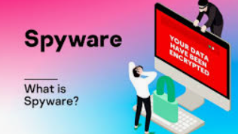 | Spyware is malicious software designed to enter your computer device, gather data about you, and forward it to a third-party without your consent.
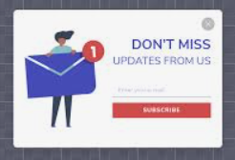 | Pop-up ads are forms of online advertising on the World Wide Web. A pop-up is a graphical user interface (GUI) display area, usually a small window, that suddenly appears ("pops up") in the foreground of the visual interface.
 | Clicking on pop-up ads can be dangerous as they can include malware or spyware which then infects your computer/tablet/phone.
 | A blog is a regularly updated website or web page, typically one run by an individual or small group, that is written in an informal or conversational style.
 | An open blog is viewable by the general public.
 | A closed blog is restricted to viewers that are chosen by the author.

Year Five – Online Safety


