Subject Specific Vocabulary
Viking | Any of the Scandinavian seafaring pirates and traders who raided and settled in many parts of north-western Europe in the 8th–11th centuries.
Anglo Saxon | Relating to or denoting the Germanic inhabitants of England from their arrival in the 5th century up to the Norman Conquest.
thatch | A roof covering of straw, reeds, palm leaves, or a similar material.
pillaged | When something is broken into and things are stolen.
turmoil | When everything feels messy, confusing, or out of control.
Picts | A group of people who lived in Scotland a long time ago.
burh | A strong, safe place or town built to protect people.
treaty | A special agreement to stop fighting or to work together.
monasteries | Places where monks live, learn, and pray.
Pagens | People who believed in many different gods before Christianity.
legislation | Making or enacting laws.
piety | Being very faithful and serious about your religion.
longboat | A large boat which may be launched from a sailing ship.
mead | An alcoholic drink made of fermented honey and water.
danegeld | A land tax levied in Anglo-Saxon England during the reign of King Ethelred to raise funds for protection against Danish invaders.
raid | A rapid surprise attack on an enemy.
trade | The action of buying and selling goods and services.
livestock | Animals and birds that are kept on a farm.

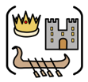
Year Five – History: Do invasions always result in change?
 | Sticky knowledge
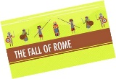 | The Roman Empire ended in 410 AD and was in turmoil across Europe. It had broken into 2 (East and West). Consequently, Roman military leaders abandoned Britain so that they could defend Rome against Germanic tribes. This led to change in Britain.
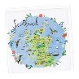 | To keep the Scots out of England the Romans built Hadrian’s wall in AD 122. According to historical enquiry, the Scots, from Ireland invaded North Britain in 410 AD where the Picts lived. As a result, this became known as Scotland
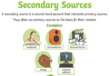 | Secondary sources often include asking questions about primary sources to interpret the past. Accurate interpretation is based on the reliability of a source.
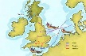 | As a consequence of the Romans leaving, Britain was easier to invade. Anglo-Saxons ruled from 410AD – 1066AD, they were a mix of tribes from Germany, Denmark and The Netherlands.
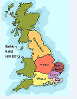 | The Anglo-Saxon word for town in “burh” and many towns today still have this as part of their name – Edinburgh. When the Anglo-Saxons first settled in Britain, there were seven kingdoms - Northumbria, Mercia, East Anglia, Wessex, Essex, Sussex, Kent but by AD 878 there was just one kingdom left. They called the land Eagle Land which became known as England.
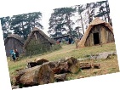 | Anglo Saxons invaded from the East and built settlements near rivers and coasts for food and farming. Anglo Saxons lived in family houses which were built using wood and straw around a central hall where the village chief lived.
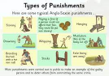 | The Anglo-Saxon were originally Pagens and superstitious. The had many Gods but adopted Christianity and many churches were built by the Anglo Saxons. They created the first laws in Britain, some are very similar to what we have today.
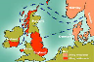 | The Vikings came from the modern Scandinavian countries of Denmark, Norway and Sweden. They first invaded Lindisfarne in AD793.
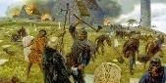 | The Vikings raided places such as monasteries to steal gold and pillaged expensive items to trade. They took inhabitants to use as slaves. They invaded and settled in Scotland before heading south to places such as York. By AD 878 the Vikings had settled permanently in Britain. They failed to rule over the kingdom of Wessex.
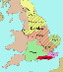  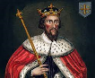 | Alfred the Great prevented England from falling to the Vikings, he defeated the Vikings at the Battle of Edington. He negotiated peace with the Danish leader Guthrum, which allowed some continuity for the Saxons. He promoted learning and literacy, he introduced defense measures, reformed the law and the use of coinage
 | By 884 a treaty was agreed that left Vikings ruling over Danelaw in the North of England. This was where the laws of the Danes dominated the Saxon laws. Danelaw ended when King Athelstan drove the Vikings out.
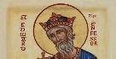 | Edward the Confessor was known for his religious faith; therefore he was called the Confessor. His life was characterised by piety and religious belief, he was the last but one of the Anglo Saxon Kings of England.
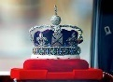 | Both the Roman and Viking invasions were significant as they have shaped our nation today and some of our ways of life. The monarchy in England (and the UK) is still in place now, although its powers have changed and have been absorbed by central government. We no longer believe in the divine right of kings.

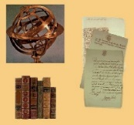
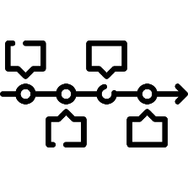
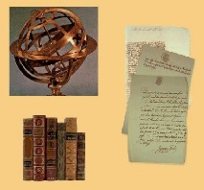
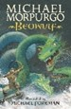
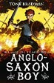
Exciting texts!
Reliable sources
Timeline



Sticky Knowledge
DT
Your design must meet the specification in the design criteria, for your audience. If a design meets all the design criteria for a particular audience, it should appeal to them
3D drawings can be annotated with the dimensions (measurements) of the product and show how it will look in real life from different perspectives. Annotations are notes and labels which record opinions, functionality or design which enable the designer to follow a plan
Prototype is a draft version of a product (a practise run). Prototypes are used to ensure the design will fully meet the design criteria. Final version – the finished product
Competently means knowing how to do something successfully. Working safely means taking precautions to minimise risk of injury to yourself
Evaluating a product against the design criteria means checking that it fully meets each criterion


Sticky Knowledge
Geography
Italy is located in Europe in the northern hemisphere.

