Subject Specific Vocabulary
competence | Having the necessary ability, knowledge, or skill to do something successfully.
confidence | Believing in yourself and your own abilities.
self-rescue | The ability to safely get out of trouble in water by staying calm, floating, and getting to safety on their own.
survival | Having the essential skills to survive a fall into water, knowing how to float, control breathing and swim to safety.
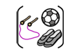

Year Five – PE – Indoor: Swimming and Gymnastics

 | Sticky knowledge
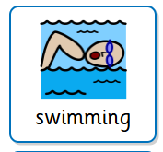 | Perform an accurate and consistent stroke on the front and back when swimming 25m.
 | Face in the water, breathing to the side, alternating arm strokes, legs straight.
 | Hands used to pull the water to help efficiency.
 | Leg kicks create small splash to improve effectiveness.
 | Personal survival stroke is where the arms remain underneath the water, especially if clothed, as this is easier than being above the water and will help to safe energy.

 | Sticky knowledge
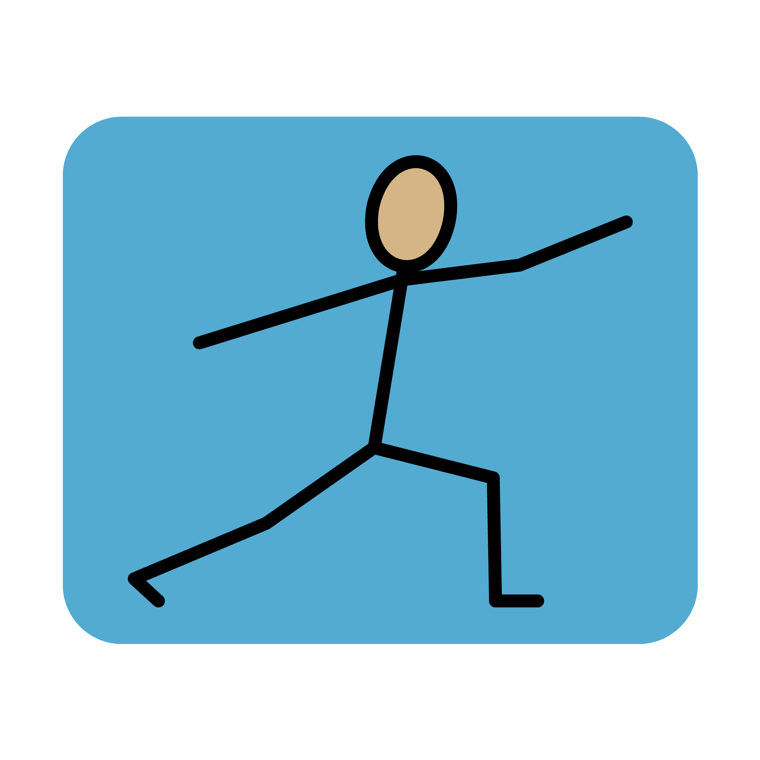 | Good gymnastics relies on core strength and body control to perform movements safely and accurately.
 | Key body shapes—tuck, pike, straddle, straight and arch—are used to show control and precision.
 | A balance must be still and held for at least 3 seconds to show control.
 | Jumps should show shape in the air and end with a controlled landing (knees bent, arms forward).
 | A gymnastics sequence should include a balance, roll, jump and travelling action, linked with smooth transitions.
Subject Specific Vocabulary
balance | Being still in one position
shape | The form you make with your body
fluency | When movements flow smoothly from one to the next.
action | The movement
combine | Putting parts together



